Contents

Building Your Tables and Views - Installing Sample Tables 1

**Introduction** 1

**Task 1: Creating the Project Tables** 1

**Task 2: Review Database Objects** 2

**Summary** 2

Building your app - Using the Create Application Wizard 3

**Introduction** 3

**Task 1: Creating an App** 3

**Task 2: Naming the App** 4

**Task 3: Add the Dashboard Page** 6

**Task 4: Add the Project Page** 10

**Task 5: Add the Milestone Pages** 12

**Task 6: Add the Tasks Pages** 14

**Task 7: Generate the App** 19

**Task 8: Runtime App** 21

**Summary** 22

**Learn More / Troubleshooting: How to change a page's name** 22

Regenerating the App 25

**Introduction** 25

**Task 1: Delete Generated App** 25

**Task 2: Reload the Projects App** 26

**Task 3: Replacing the Milestone Pages** 27

**Task 4: Add the Status Page** 29

**Task 5: Completing the App** 30

**Summary** 32

Improving the Dashboard 33

**Introduction** 33

**Task 1: Removing Chart 4** 33

**Task 2: Move Regions** 35

**Summary** 38

Improving Projects 39

**Introduction** 39

**Task 1: Changing the Cards Region Style** 39

**Task 2: Enhancing Projects Page** 40

**Task 3: Adding a Form Page** 43

**Task 4: Link to Projects Page** 46

**Task 5: Update How Items are Displayed** 51

**Task 6: Improve the Completed Date** 54

**Summary** 58

Improving Milestones 59

**Introduction** 59

**Task 1: Change the Name Column** 59

**Task 2: Update the Grid Layout** 60

**Task 3: Save the Report** 62

**Summary** 63

Improving Tasks 64

**Introduction** 64

**Task 1: Defining a Shared List of Values** 64

**Task 2: Updating the Faceted Search** 67

**Task 3: Updating the Interactive Report** 71

**Task 4: Linking the Calendar** 72

**Summary** 76

# Building Your Tables and Views - Installing Sample Tables

**Introduction**

In this lab, you will learn how to install sample tables and views from Sample Datasets, which come complete with sample data.

Collapse All Tasks

**Task 1: Creating the Project Tables**

1. From your APEX workspace home page, select **SQL Workshop**, click **Utilities**, and then click **Sample Datasets**.

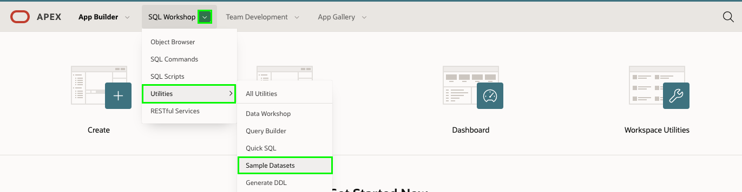

1. On the **Project Data** row, click **Install**.

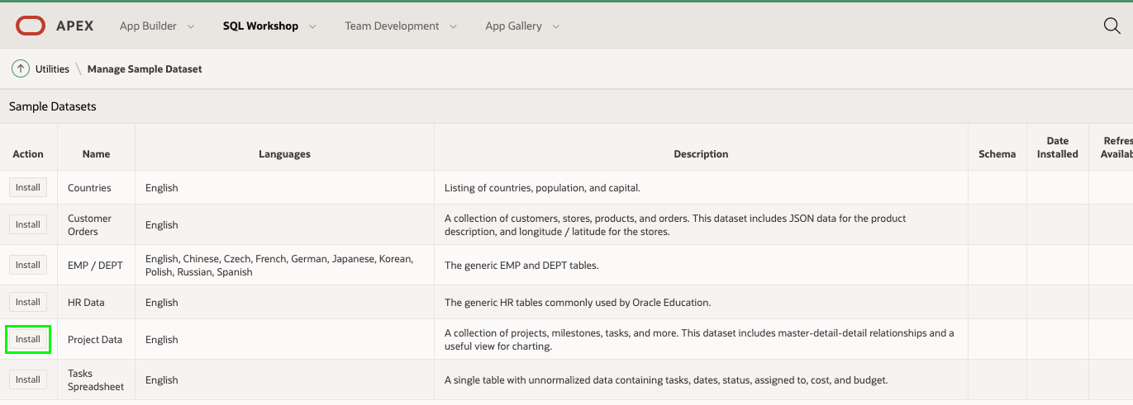

1. Click **Next**.
2. Click **Install Dataset**.
3. Click **Exit**.  
   *Note: You do NOT want to click Create Application, as you will manually create an application*

**Task 2: Review Database Objects**

1. In the App Builder Menu, click **SQL Workshop**.
2. Click **Object Browser**.

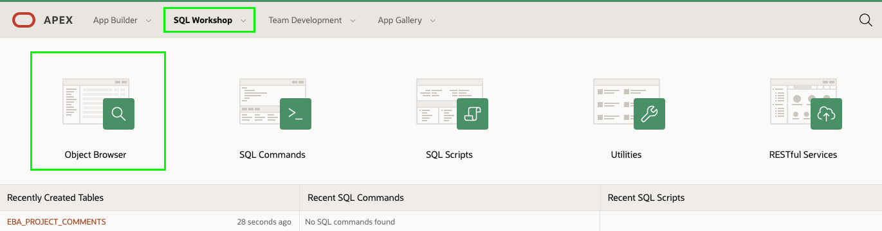

1. Click on the tables starting with **EBA_** and the various tabs, such as Data, Constraints, and so forth, to review the table details.

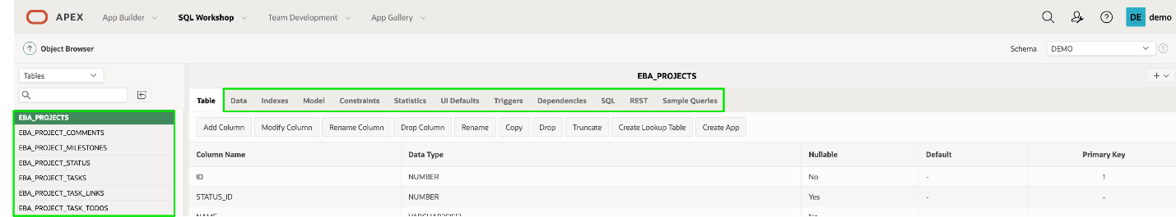

**Summary**

This completes Lab 1. You now know how to install a sample dataset.

# Building your app - Using the Create Application Wizard

**Introduction**

In this lab, you will learn how to create the initial app based on existing tables in your Oracle database. In practice, you will generally start with only one or two pages, and then use the Create Page Wizard to add additional pages to your app.

Collapse All Tasks

**Task 1: Creating an App**

1. In the App Builder menu, click **App Builder**.
2. Click **Create**.

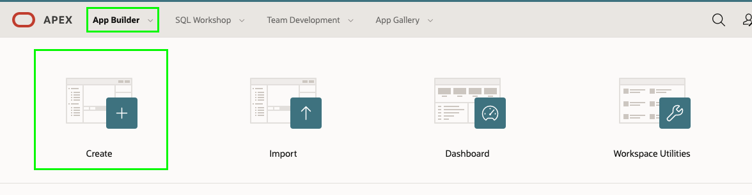

1. Click **New Application**.

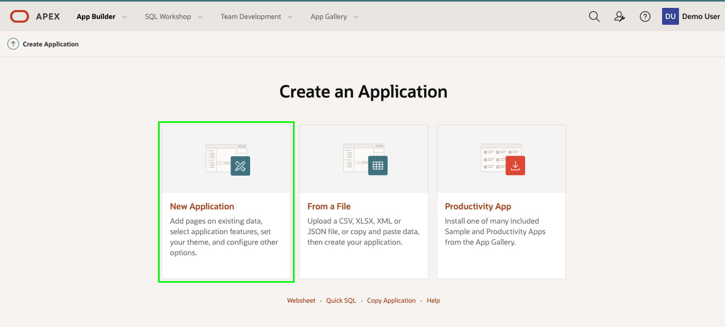

**Task 2: Naming the App**

1. In the Create Application wizard, for Name enter **Projects**.
2. Click **Set Appearance** button in Appearance.

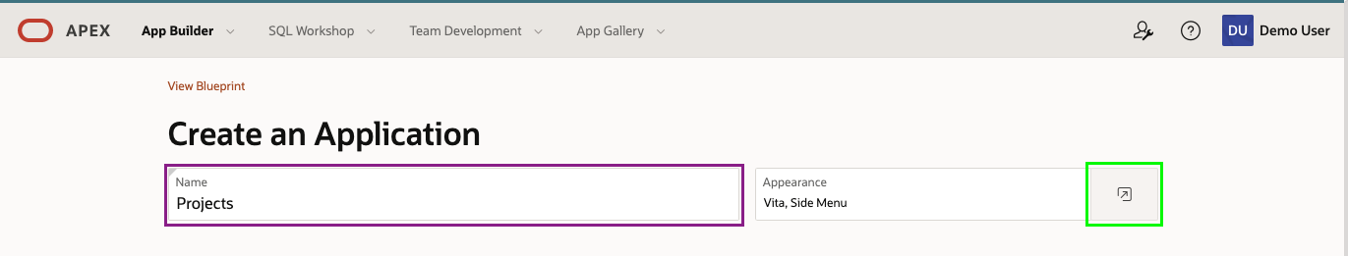

1. On the Appearance dialog, for Theme Style select **Vita – Slate**.
2. Click **Choose New Icon**.

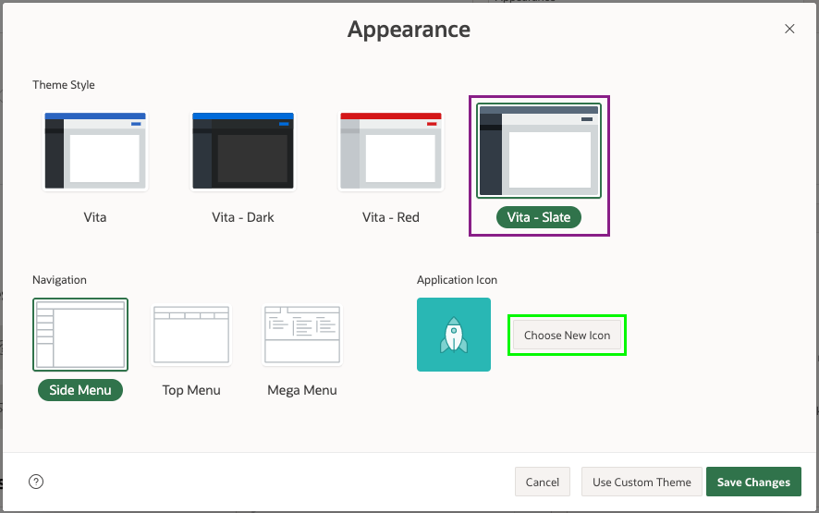

1. On the Choose Application Icon dialog, select an icon color and an icon of your choosing.

Click **Set Application Icon**.

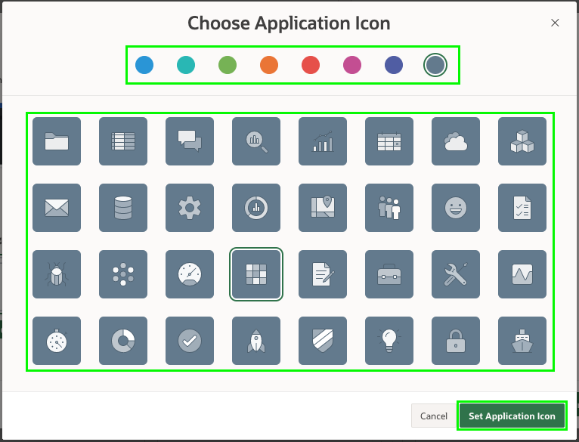

1. Click **Save Changes**.

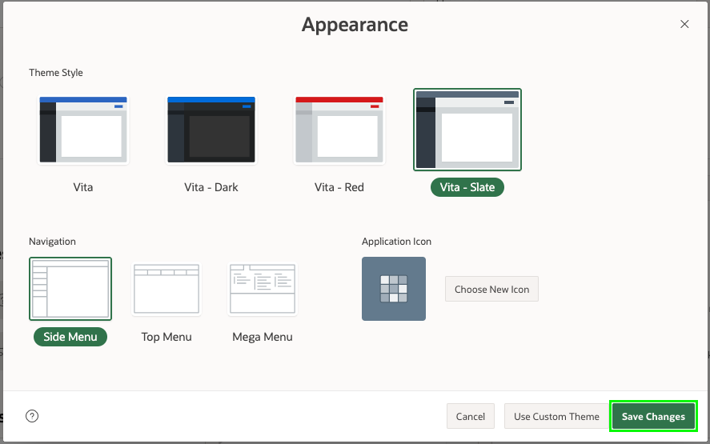

**Task 3: Add the Dashboard Page**

A dashboard page is a great way to show important information using various charts. When you created the Sample Dataset, it also created a view **EBA_PROJECTS_V**, which joins data from various tables. This view is ideal as the basis for the dashboard charts.

1. In the Create Application wizard, click **Add Page**.
2. Click **Dashboard**.

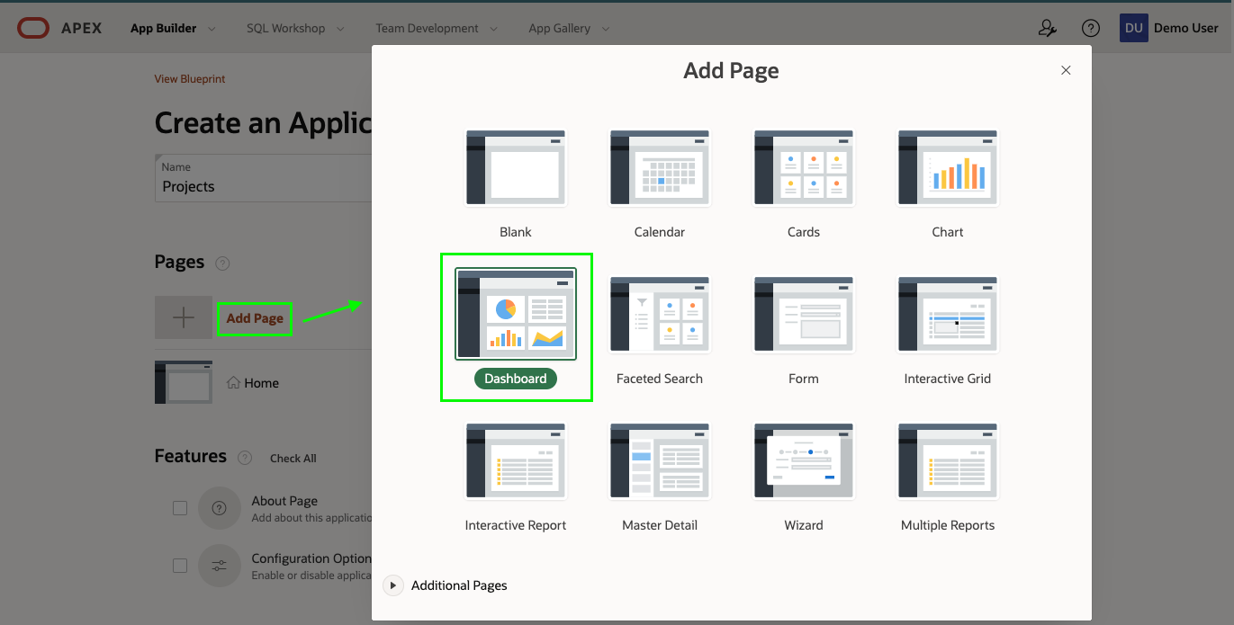

1. For **Chart 1**, enter the following:
   * Chart Type – select **Bar**
   * Chart Name – enter **Budget versus Cost**
   * Table or View – select **EBA_PROJECTS_V**
   * Label Column – select **NAME**
   * Value Column – select **BUDGET_V_COST**

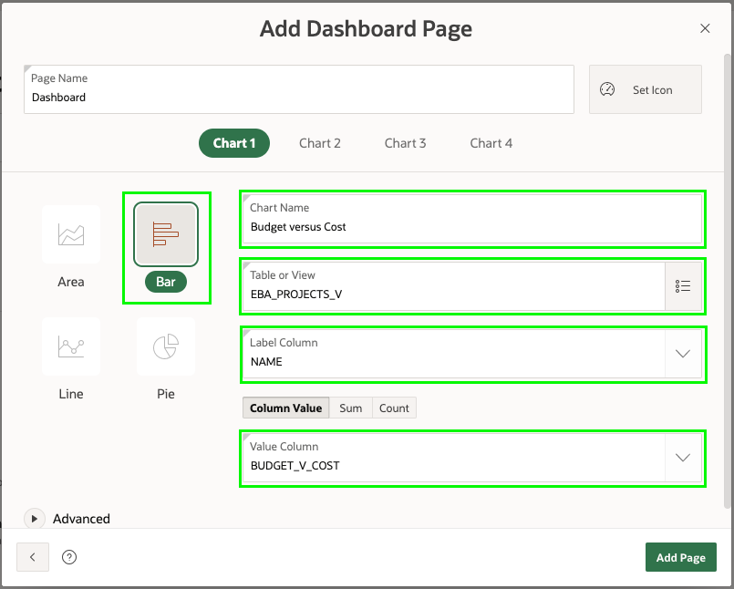

1. Click **Chart 2**, and enter the following:
   * Chart Type – select **Pie**
   * Chart Name – enter **Project Status**
   * Table or View – select **EBA_PROJECTS_V**
   * Label Column – select **Status**
   * Type – select **Count**

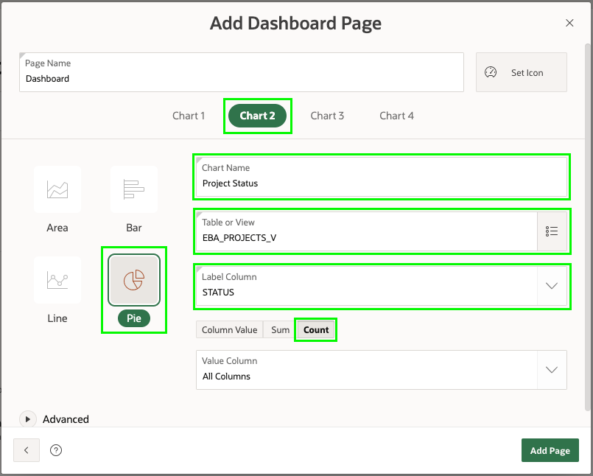

1. Click **Chart 3**, and enter the following:
   * Chart Type – select **Bar**
   * Chart Name – enter **Project Leads**
   * Table or View – select **EBA_PROJECTS_V**
   * Label Column – select **PROJECT_LEAD**
   * Type – select **Count**
2. Click **Add Page**

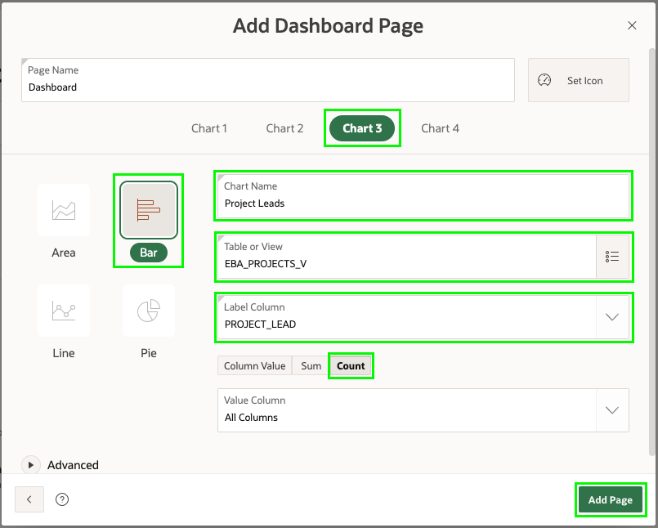

*Note: You have not set any values for Chart 4; therefore, it will be generated with a chart based on demo data. In a later lab, we will remove this additional chart.*

**Task 4: Add the Project Page**

Card pages are especially good when there is not a huge number of records, and you want to display only a few details. The **EBA_PROJECTS** table only has 12 records and would work well as a card page.

1. In the Create Application wizard, click **Add Page**.
2. Click **Cards**.

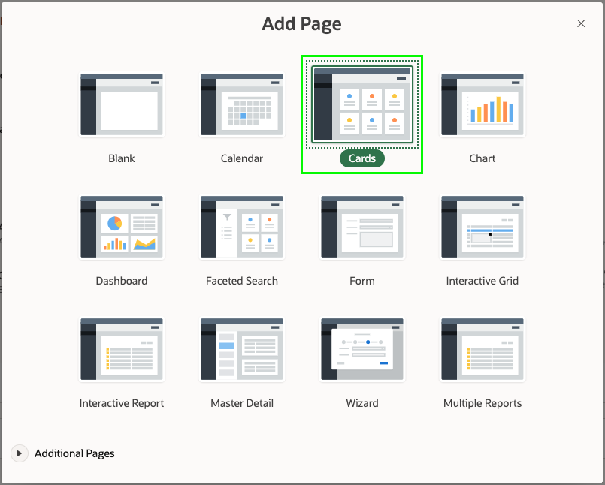

1. On the Add Cards Page, enter the following:
   * Page Name - enter **Projects**
   * Table or View - select **EBA_PROJECTS**
   * Title Column - select **NAME**
   * Body Column - select **Description**
   * Icon Initials Column - select **NAME**
   * Badge Column - select **COMPLETED_DATE**
2. Click **Add Page**

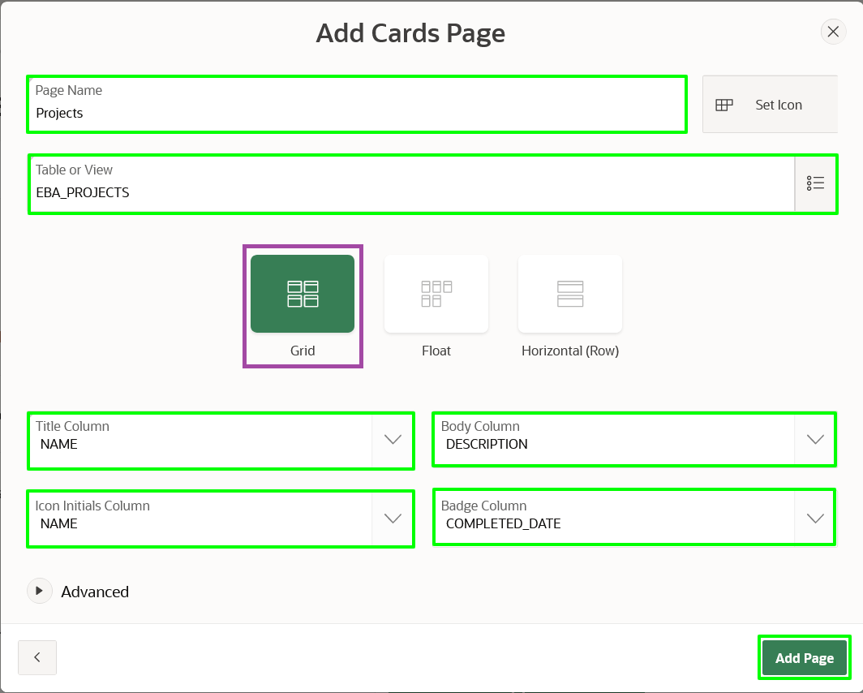

**Task 5: Add the Milestone Pages**

There are 30 records within **EBA_MILESTONES**. Therefore, you will add a report page and an associated form page.

1. In the Create Application wizard, click **Add Page**.
2. Click **Interactive Report**.

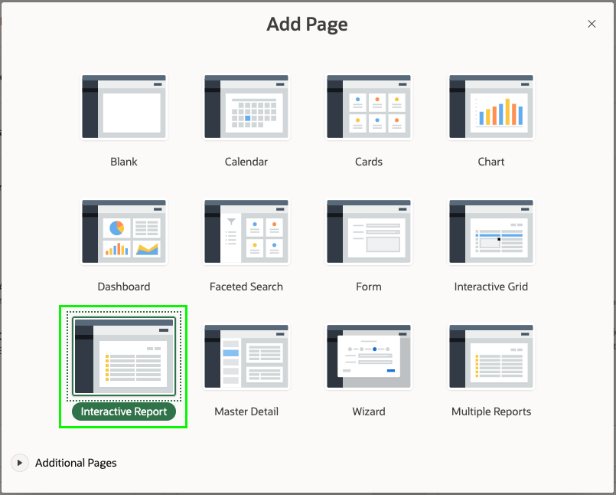

1. On the Add Report Page, enter the following:
   * Page Name - enter **Milestones**
   * Table or View - select **EBA_PROJECT_MILESTONES**
   * Check **Include Form**

Expand **Lookup Columns**:

* + Lookup Key 1 - select **PROJECT_ID**
  + Display Col 1 - select **EBA_PROJECTS.NAME**

1. Click **Add Page**

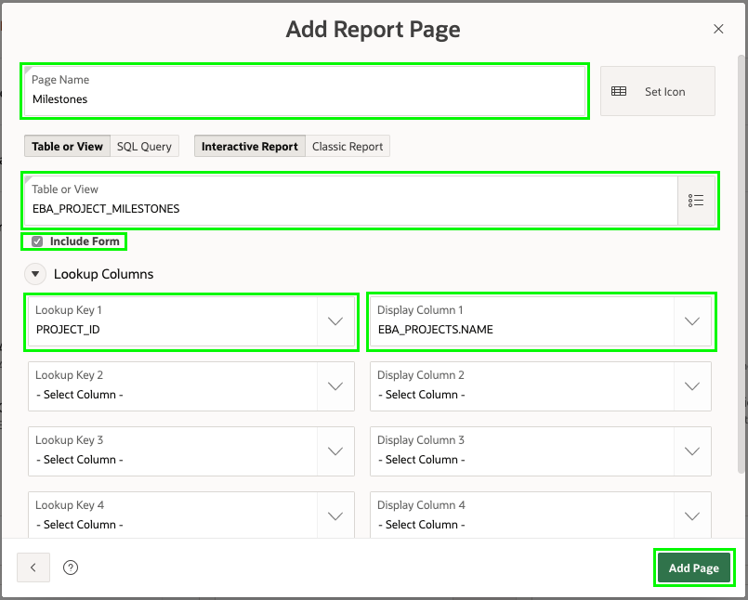

**Task 6: Add the Tasks Pages**

The **EBA_PROJECT_TASKS** table is the primary table, where records will be reviewed and updated the most. Therefore, you will add a Faceted Search page, Report and Form pages, and a Calendar page on this table.

1. In the Create Application wizard, click **Add Page**.
2. Click **Faceted Search**.

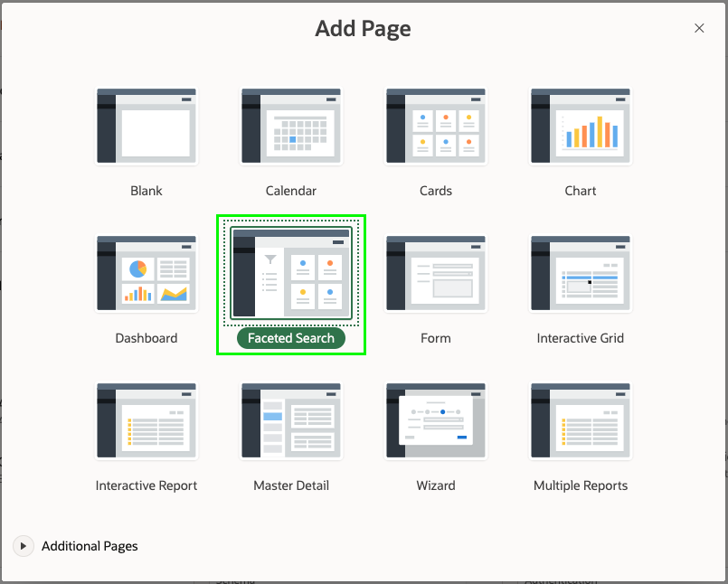

1. On the Add Faceted Search Page, enter the following:
   * Page Name - enter **Tasks Search**
   * Table - select **EBA_PROJECT_TASKS**
2. Click **Add Page**

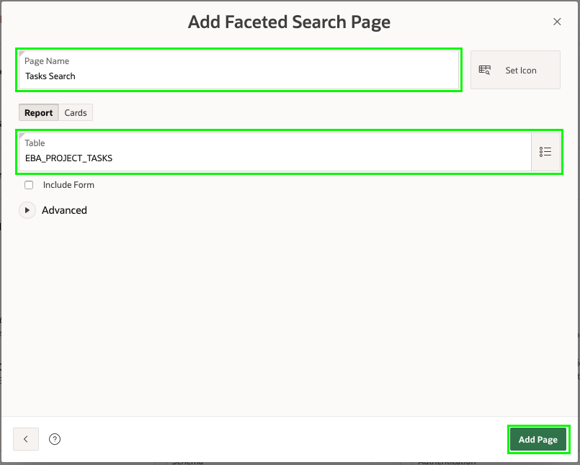

1. It would be better to place the **Tasks Search** page up under the **Dashboard** page.

For **Tasks Search** click and hold the hamburger (four parallel bars), after the Edit button.  
Drag the page up until it displays between the **Dashboard** page and the **Projects** page.  
Release the mouse.

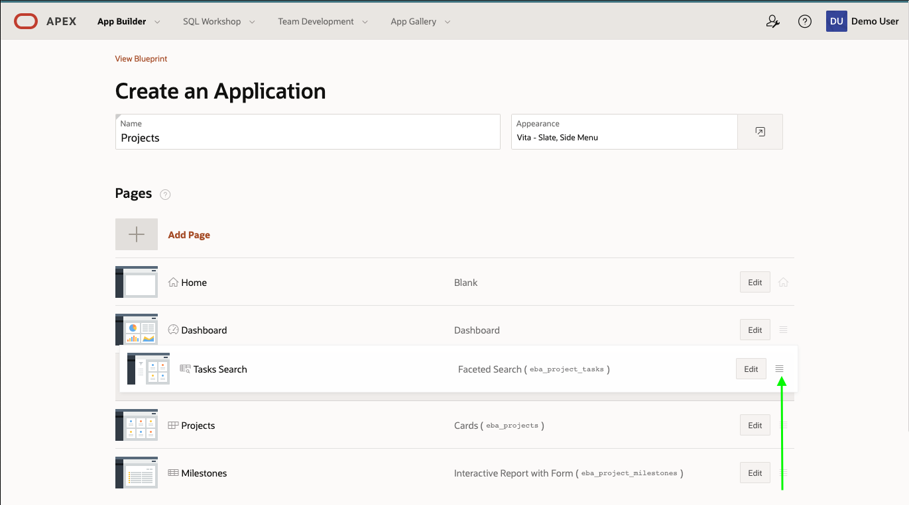

1. Now to add the Report and Form pages.  
   In the Create Application wizard, click **Add Page**.
2. Click **Interactive Report**.
3. On the Add Report Page, enter the following:
   * Page Name - enter **Tasks Report**
   * Table or View - select **EBA_PROJECT_TASKS**
   * Check **Include Form**

Expand **Lookup Columns**

* + Lookup Key 1 - select **PROJECT_ID**
  + Display Col 1 - select **EBA_PROJECTS.NAME**
  + Lookup Key 2 - select **MILESTONE_ID**
  + Display Col 2 - select **EBA_PROJECT_MILESTONES.NAME**

1. Click **Add Page**

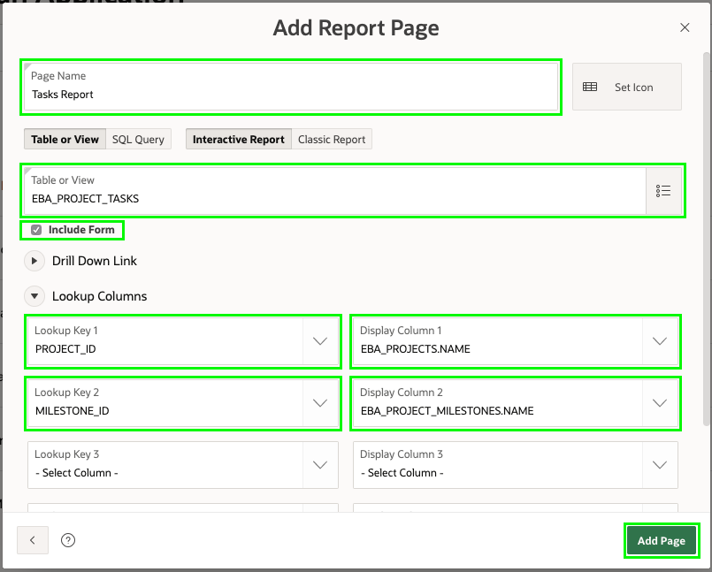

1. Last we will add a Calendar.  
   In the Create Application wizard, click **Add Page**
2. Click **Calendar**.
3. On the Add Calendar Page, enter the following:
   * Page Name - enter **Tasks Calendar**
   * Table or View - select **EBA_PROJECT_TASKS**
   * Display Column - select **NAME**
   * Start Date Column - select **START_DATE**
   * End Date Column - select **END_DATE**
4. Click **Add Page**

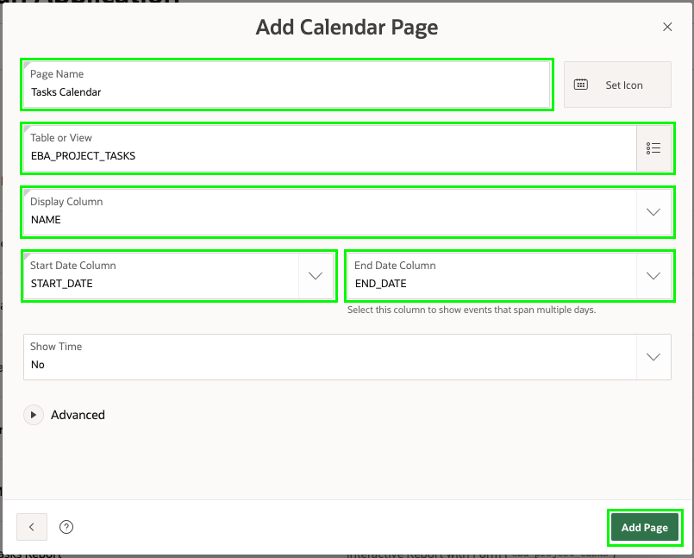

*Note: If you go to****SQL Workshop****>****Object Browser****, select the****EBA_PROJECT_TASKS****table, and then click****Create App****, it will create an app with a Dashboard page, Faceted Search page, Report and Form pages, and a Calendar page (if appropriate) all based on the selected table. This technique provides a great starting point for creating your apps, especially if you are not sure what pages you want up front.*

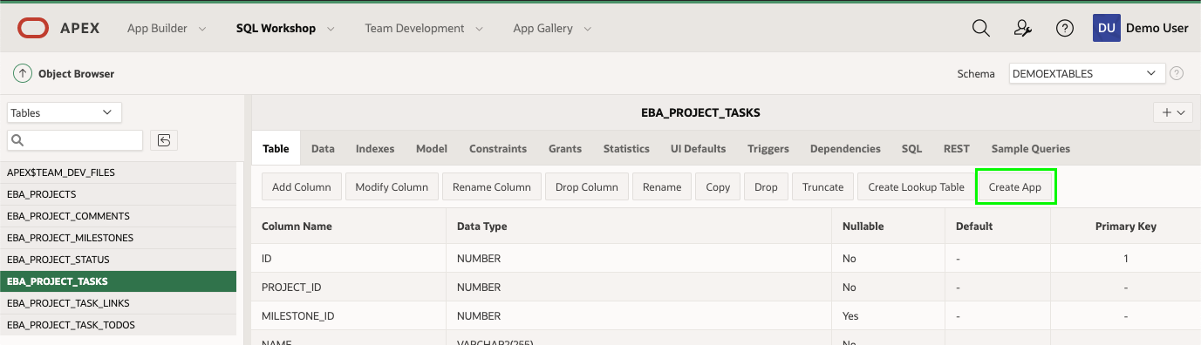

**Task 7: Generate the App**

Now that you have added all the pages, it is time to generate the app and review it.

1. Scroll to the bottom of the page, and click **Create Application**.

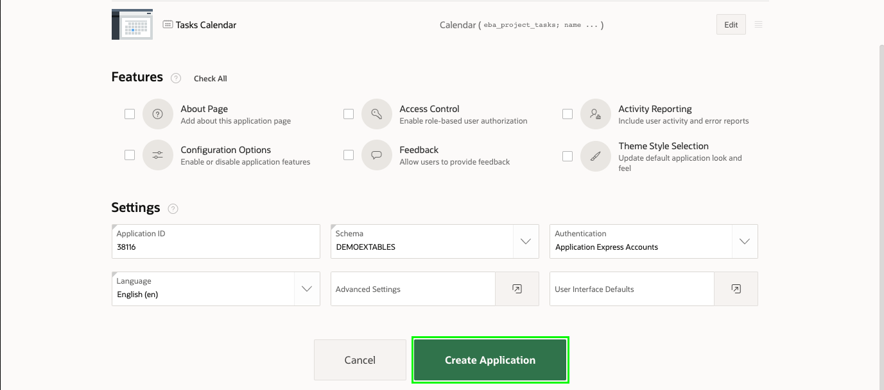

1. Once the application has been generated, your new app will be displayed in the application home page.

Click **Run Application**.

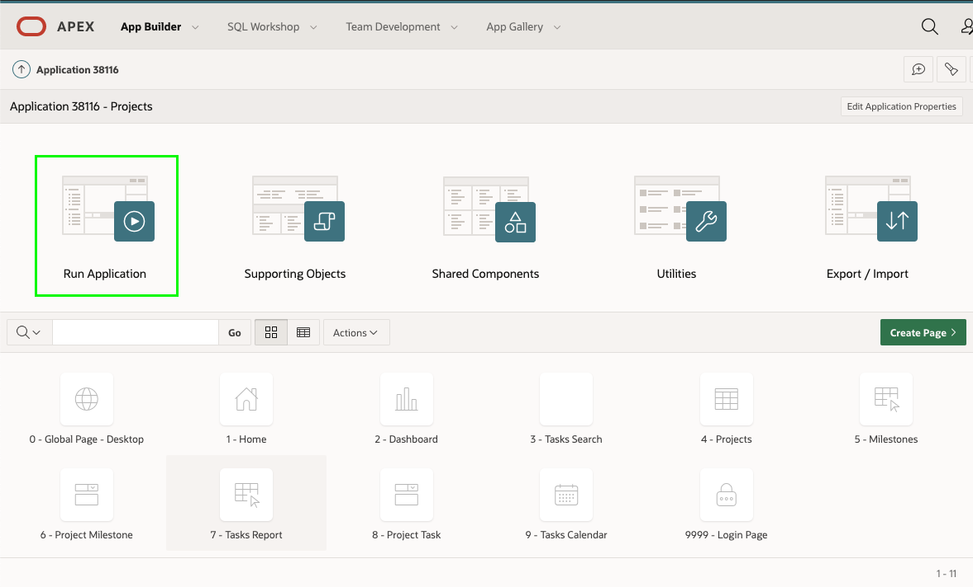

**Task 8: Runtime App**

1. Enter your user credentials. Click **Sign In**.

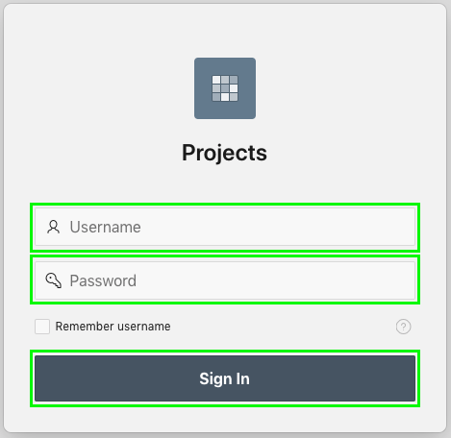

1. This is your *Runtime Environment*. Play around with your new application!

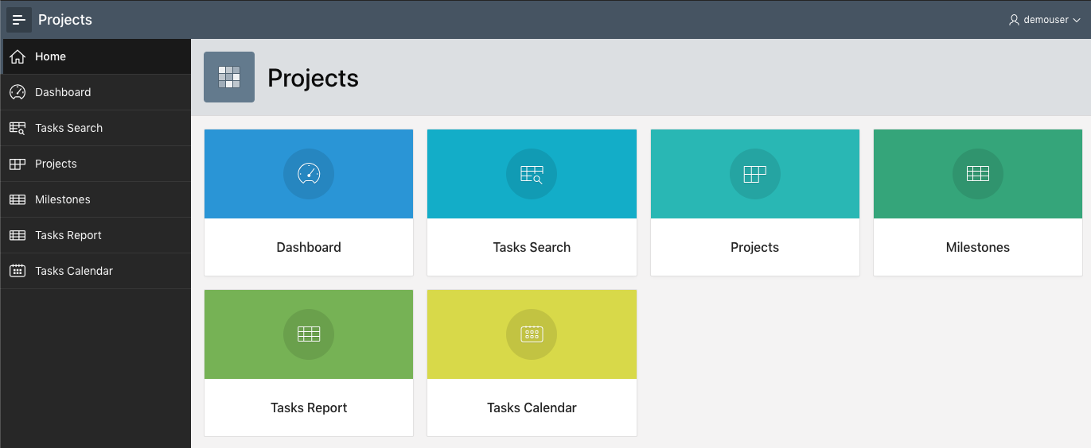

**Summary**

This completes Lab 2. You now know how to create an application, with numerous different page types, based on existing database objects. [Click here to navigate to Lab 3](https://oracle-livelabs.github.io/apex/existing-tables/workshops/freetier/index.html?lab=lab-3-regenerating-app&customTrackingParam=:ow:lp:cpo::::RC_%20WWMK211125P00013:llid&customTrackingParam=:ow:lp:cpo::::RC_%20WWMK211125P00013:llid&customTrackingParam=:ow:lp:cpo::::RC_%20WWMK211125P00013:llid)

**Learn More / Troubleshooting: How to change a page's name**

If you want to change a page's name after you create an application, the process is involved. Though it is recommended that you give a page an accurate name at the beginning, here are the instructions on how you can change a page's name.

1. In *App Builder*, click you Project. In you Project home page, click the page you want to edit. In *Page Designer*, change **Identification > Name** and **Identification > Title** to the new name. Click **Save and Run Page**. In the runtime environment, you will see the tab's name is updated.

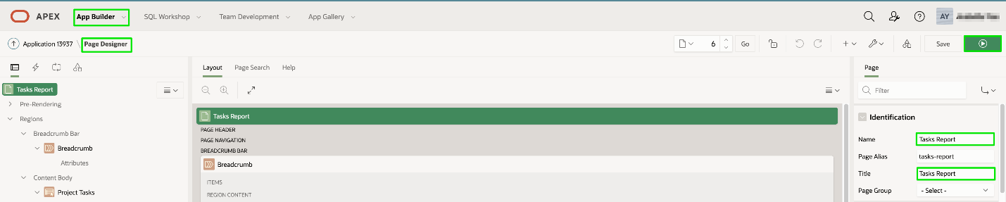

1. In your Project home page, click **Shared Component** in the development toolbar.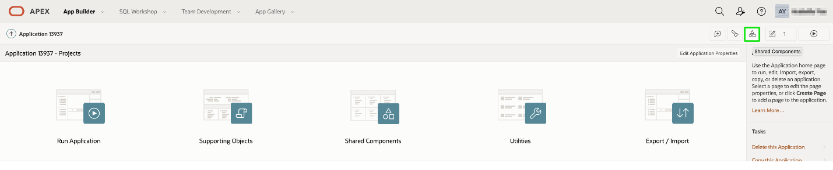

In Shared Component home page, under **Navigation**, click **Breadcrumbs**. Click **Breadcrumbs** again, click the page you want to edit.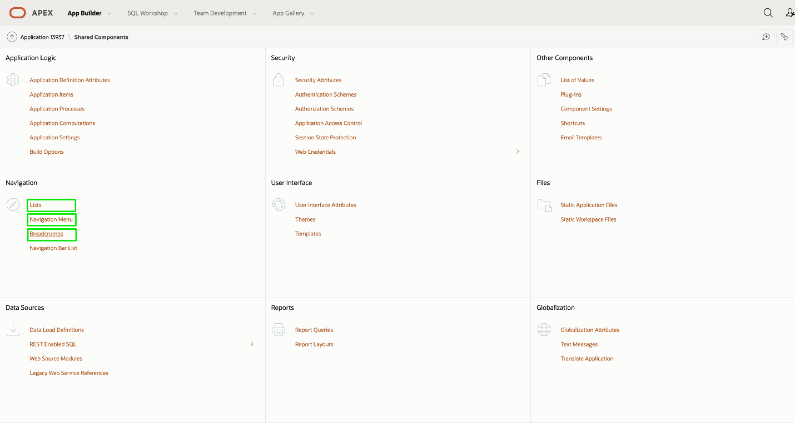

Change **Entry > Short Name** to the new name. Click **Apply Changes**. In the runtime environment, you will see the title of the page is updated.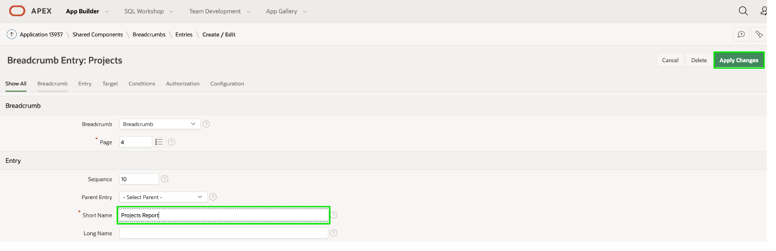

1. In Shared Component home page, under **Navigation**, click **Navigation Menu**, click **Desktop Nagivation Menu**. Click the page you want to edit, change **Entry > List Entry Label** to the new name. Click **Apply Changes**. You will see the page's name is updated on the left navigation menu.

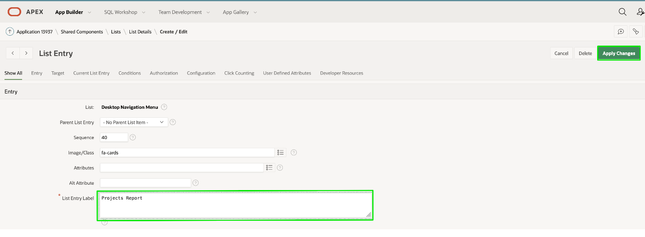

1. In Shared Component home page, under **Navigation**, click **Lists**, then click **Page Navigation**. Click the page you want to edit, change **Entry > List Entry Label** to the new name. Click **Apply Changes**. You will see the page's name is updated in the Home page of you application.

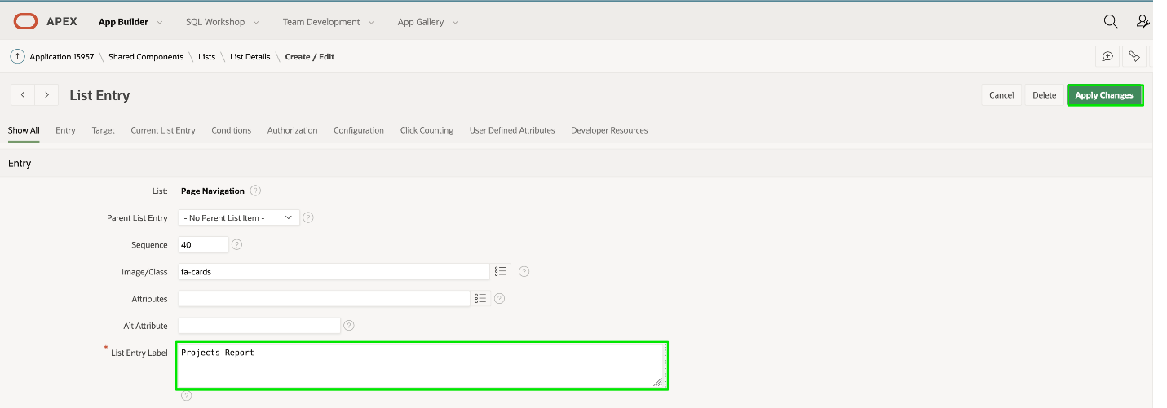

# Regenerating the App

**Introduction**

In the runtime environment, if you navigate to Milestones, and then from the report page, click the edit icon, the form page for maintaining milestones will be displayed. You will notice that there are only a few fields. Therefore, it may be better to utilize an Interactive Grid, which is similar to a spreadsheet, where several records can be maintained directly within the grid.

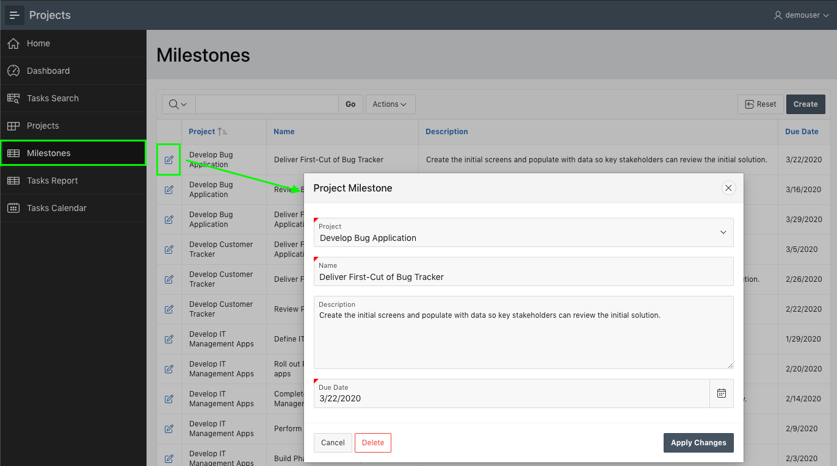

*Note: See how to go to your runtime environment from the previous lab.*

Collapse All Tasks

**Task 1: Delete Generated App**

Given you are going to regenerate the app from the Create Application Wizard, it is best to delete the app you just generated to avoid confusion.

1. In the runtime environment, within the develop toolbar, click **Application xxxxx**.



*Note: The Developer Toolbar is only shown to developers who run the application from the App Builder. End users will never be shown the Developer Toolbar*

1. From the App Home Page, under Tasks, click **Delete this Application**.

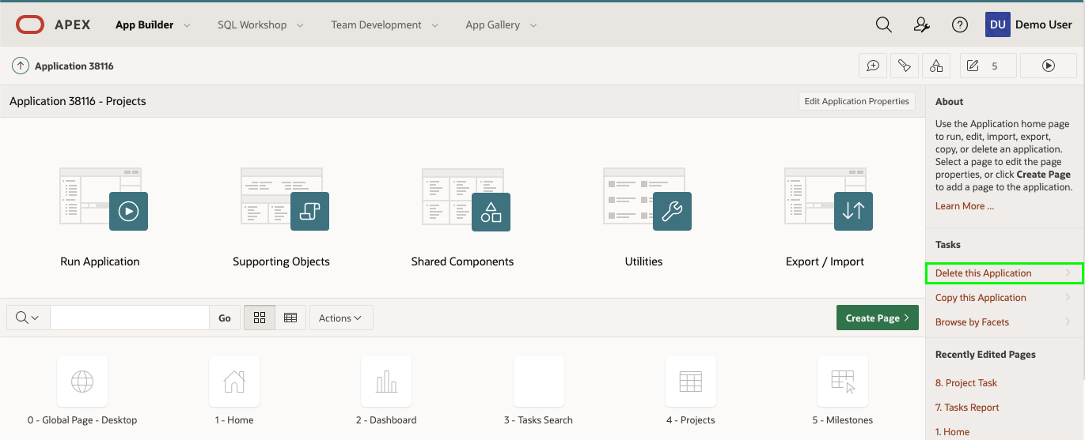

1. On the Confirm Delete page, click **Permanently Delete Now**.

**Task 2: Reload the Projects App**

The Create Application Wizard includes the ability to reload apps that you previously generated, making it easy to make some changes and generate a new and improved version of the initial app.

1. From the App Builder Home Page, click **Create**.

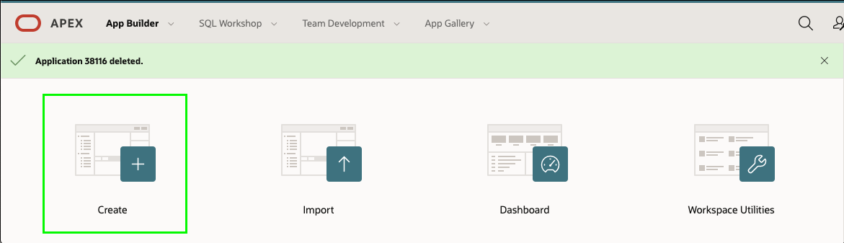

1. Click **New Application**.
2. Click **Load Blueprint**.  
   On Load Blueprint, for the latest app generated, click **Load**.

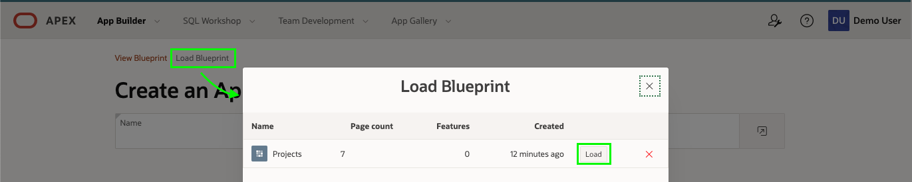

The previously defined app blueprint will be displayed.

**Task 3: Replacing the Milestone Pages**

Rather than having two ways to maintain milestone records, you will delete the original report and form pages, and then add a new page, and reposition it in the list of pages.

1. In the list of pages, for Milestones, click **Edit**.
2. Click **Delete**.

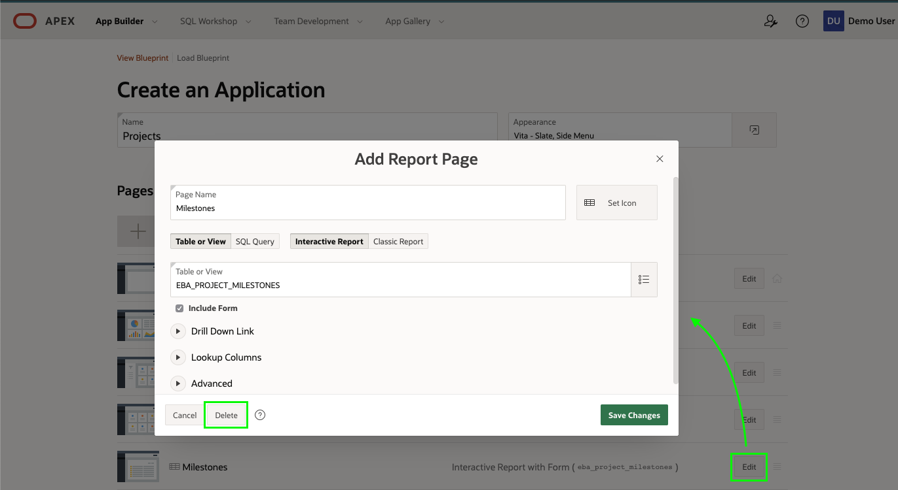

1. In the Create Application Wizard, click **Add Page**.
2. Click **Interactive Grid**.
3. On the Add Interactive Grid Page, enter the following:
   * Page Name - enter **Milestones**
   * Table or View - select **EBA_PROJECT_MILESTONES**
   * Click **Add Page**

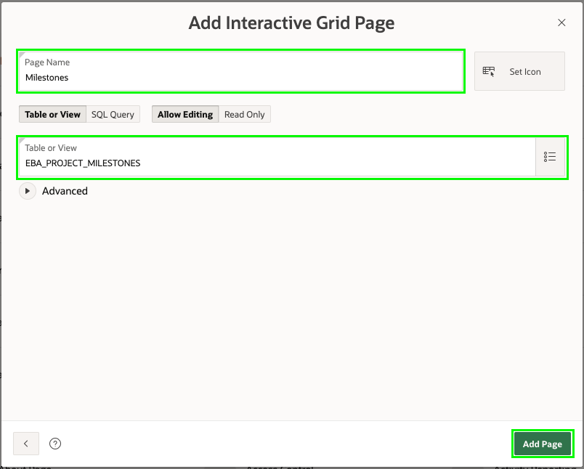

1. Now to reorder the new page.

In the list of Pages, for the Milestones page, select the hamburger.  
Drag the page up until it is under the Projects page and drop.

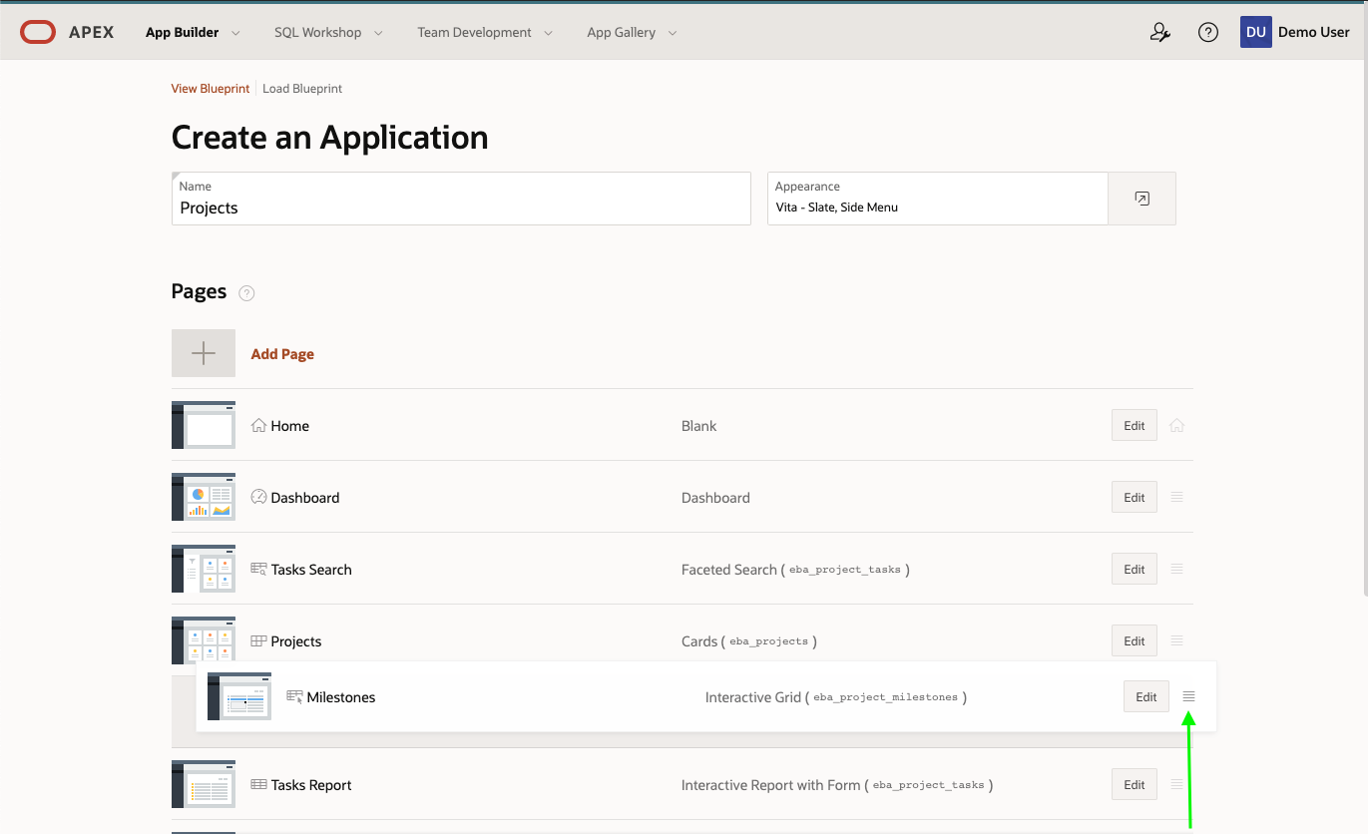

**Task 4: Add the Status Page**

The **EBA_PROJECT_STATUS** table is used to maintain project statuses. This table should be maintainable; however, only application administrators should be able to modify records. As such, adding the Status page under Administration is the optimal solution.

1. In the Create Application Wizard, click **Add Page**.
2. Click **Interactive Grid**.
3. On the Add Interactive Grid Page, enter the following:
   * Page Name - enter **Statuses**
   * Table or View - select **EBA_PROJECT_STATUS**
   * Expand **Advanced**
     + Click **Set as Administration Page**
   * Click **Add Page**

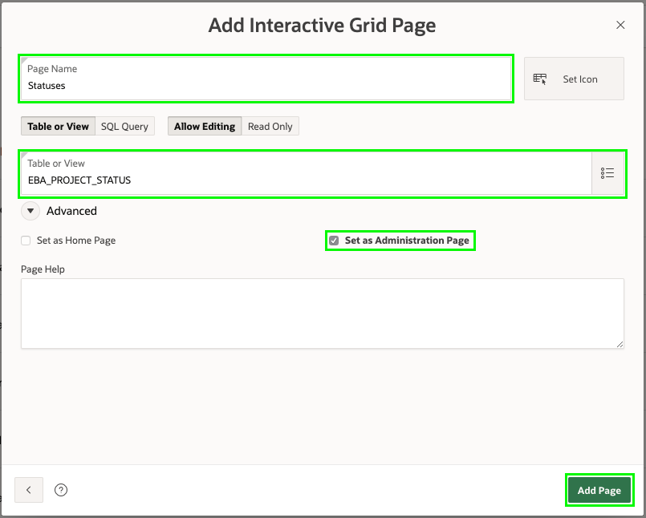

**Task 5: Completing the App**

The Create Application Wizard also has the ability to add various features to your app, such as Access Control, Activity Reporting, Feedback, and more, to make your app more functionally complete and "production-ready".

1. In the Create Application Wizard, for Features, click **Check All**
2. Click **Create Application**

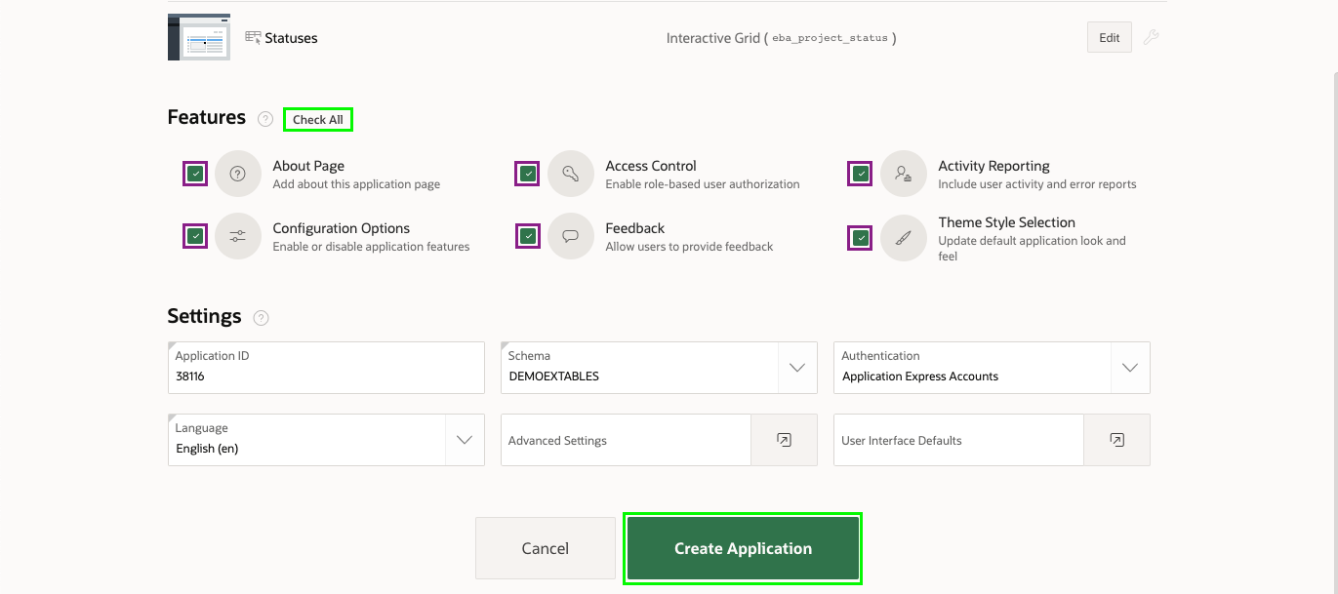*Note: Your new application will generally have a new Application Id*

Your new application will be displayed in the App Builder.

1. Click **Run Application**.
2. Enter your user credentials.
3. Navigate to **Milestones**.
4. Double-click in any column to see how you can enter data directly into the grid.

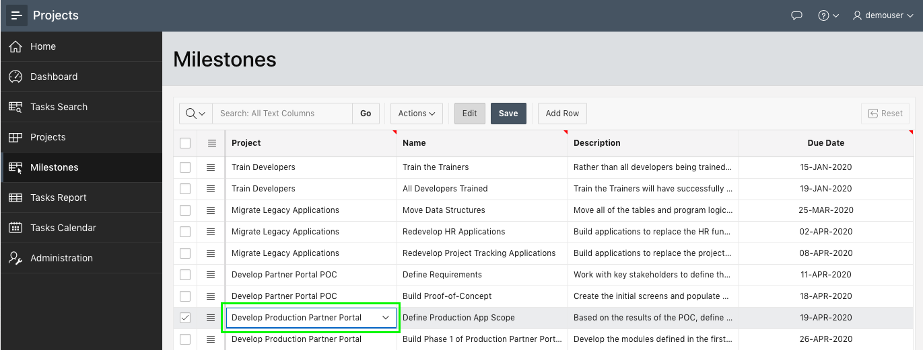

*Note: Project column will display a list of projects, Name and Description columns will be text areas, and Due Date column will be a date picker, based on the different data types.*

1. Click the navigation button at the top-left of the page, and navigate to **Administration** to review the capabilities provided.

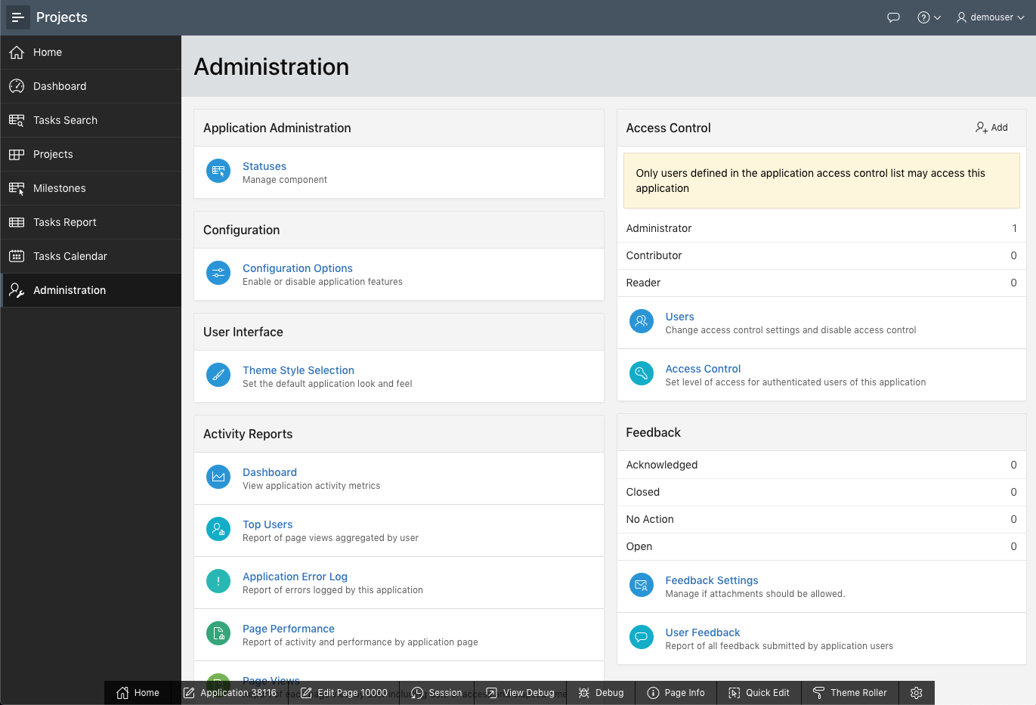

**Summary**

This completes Lab 3. You now know how to regenerate an application and add additional features.

# Improving the Dashboard

**Introduction**

In this lab, you will learn how to manipulate regions in Page Designer to improve your Dashboard.

Collapse All Tasks

**Task 1: Removing Chart 4**

Looking at the Dashboard, you will see that Chart 4 is based on demo data and should be removed.

1. In the runtime environment, click **Dashboard**.
2. In the Developer Toolbar (at the bottom of the runtime page), click **Edit Page 2**.

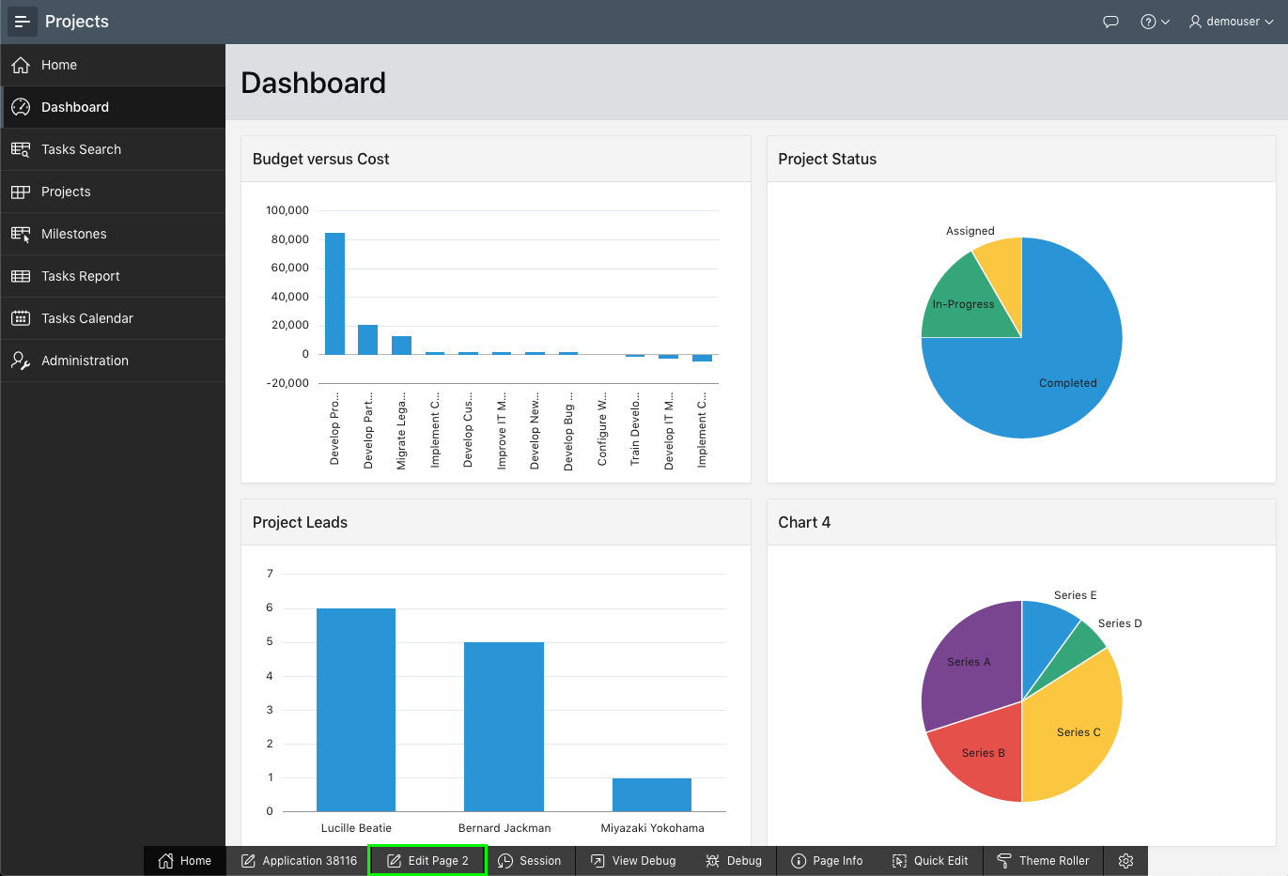

You should now be in *Page Designer*. Page Designer is where you will spend the majority of your time improving your application. There are three panes within Page Designer. The left pane initially displays the Rendering tree, with a list of page components. The middle pane displays the Layout, a representation of the page, and Gallery (in the bottom), from which you can drag and drop new components into the Layout. The right pane is the Property Editor, where you can change attributes for the selected component.

*Note: If you don't see the Developer Toolbar at the bottom of your page, try closing the current runtime environment and reaccessing it from the App Builder.*

1. Within Page Designer, in the Rendering tree (left pane), scroll down and *right-click* **Chart 4** and select **Delete**.

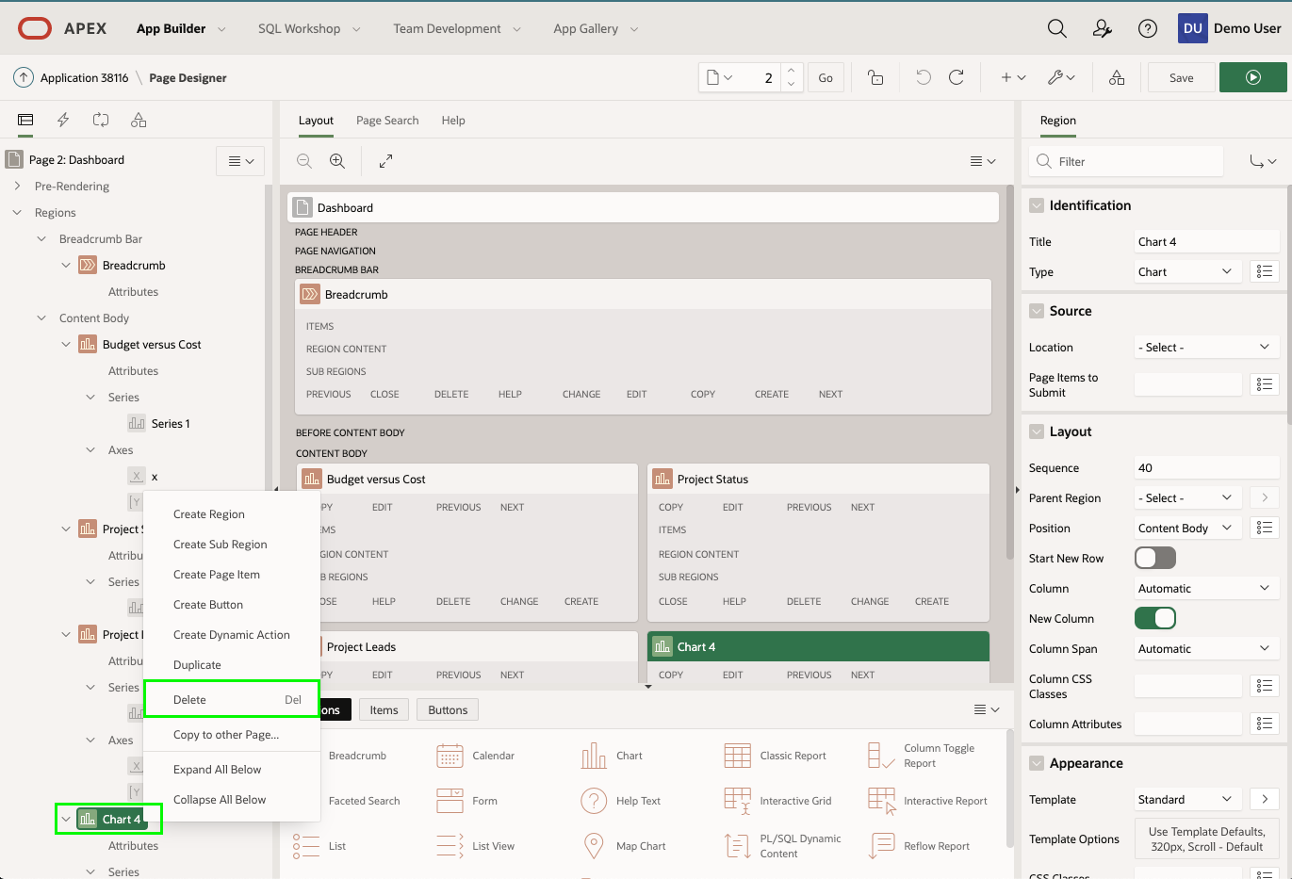

1. Let’s review the dashboard again.  
   In the Page Designer toolbar (at the top of your screen), click **Save and Run Page** button.

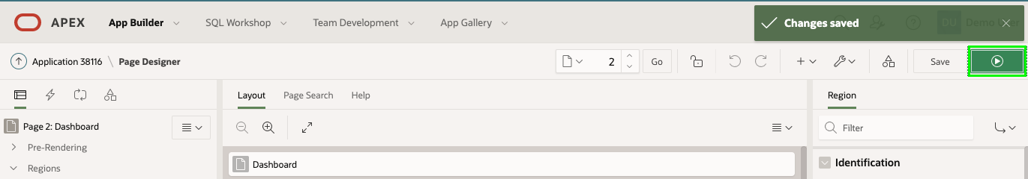

The revised layout will be displayed.

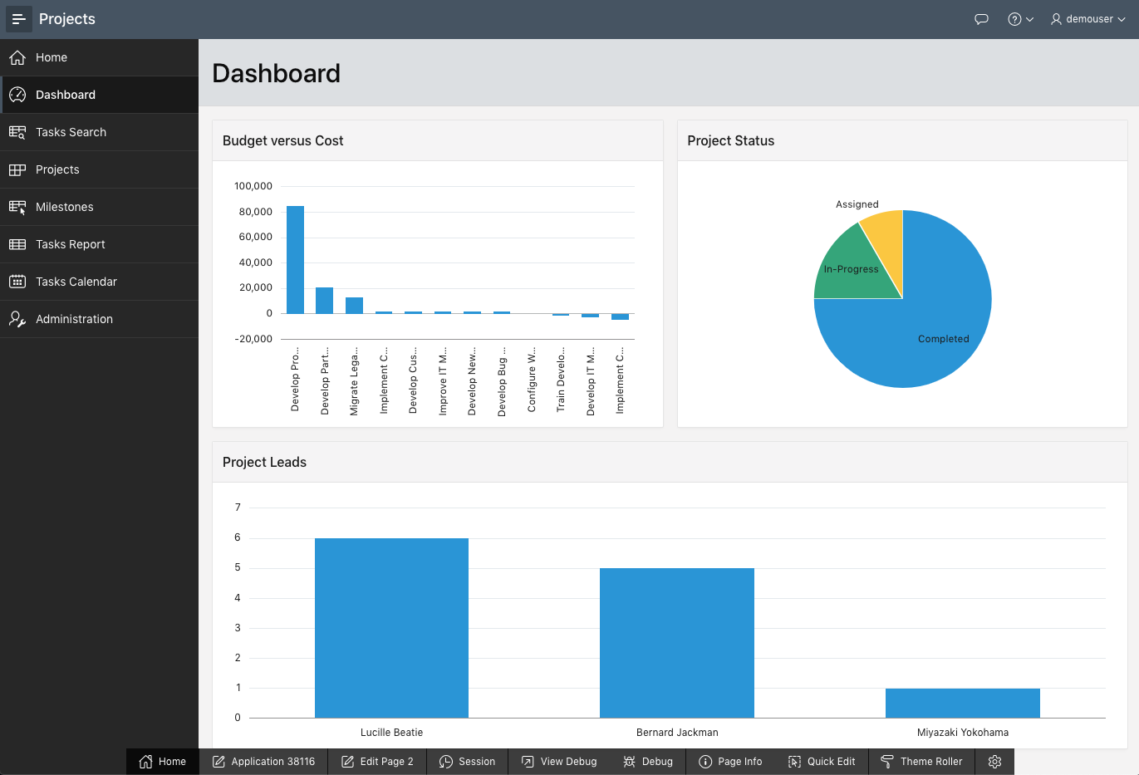

**Task 2: Move Regions**

Looking at the revised Dashboard page, it would look better to have the Budget versus Cost chart on a line by itself.

1. From the runtime environment, navigate back to the App Builder by clicking **Edit Page 2** in the Developer Toolbar, or by navigating back to the App Builder browser tab manually.
2. Within Page Designer, in the Rendering tree (left pane), click **Project Status**.  
   In the Property Editor (right pane), ***check*** **Layout > Start New Row**.  
   *Note: Within Layout (middle pane), the Project Status region will move onto a row by itself*

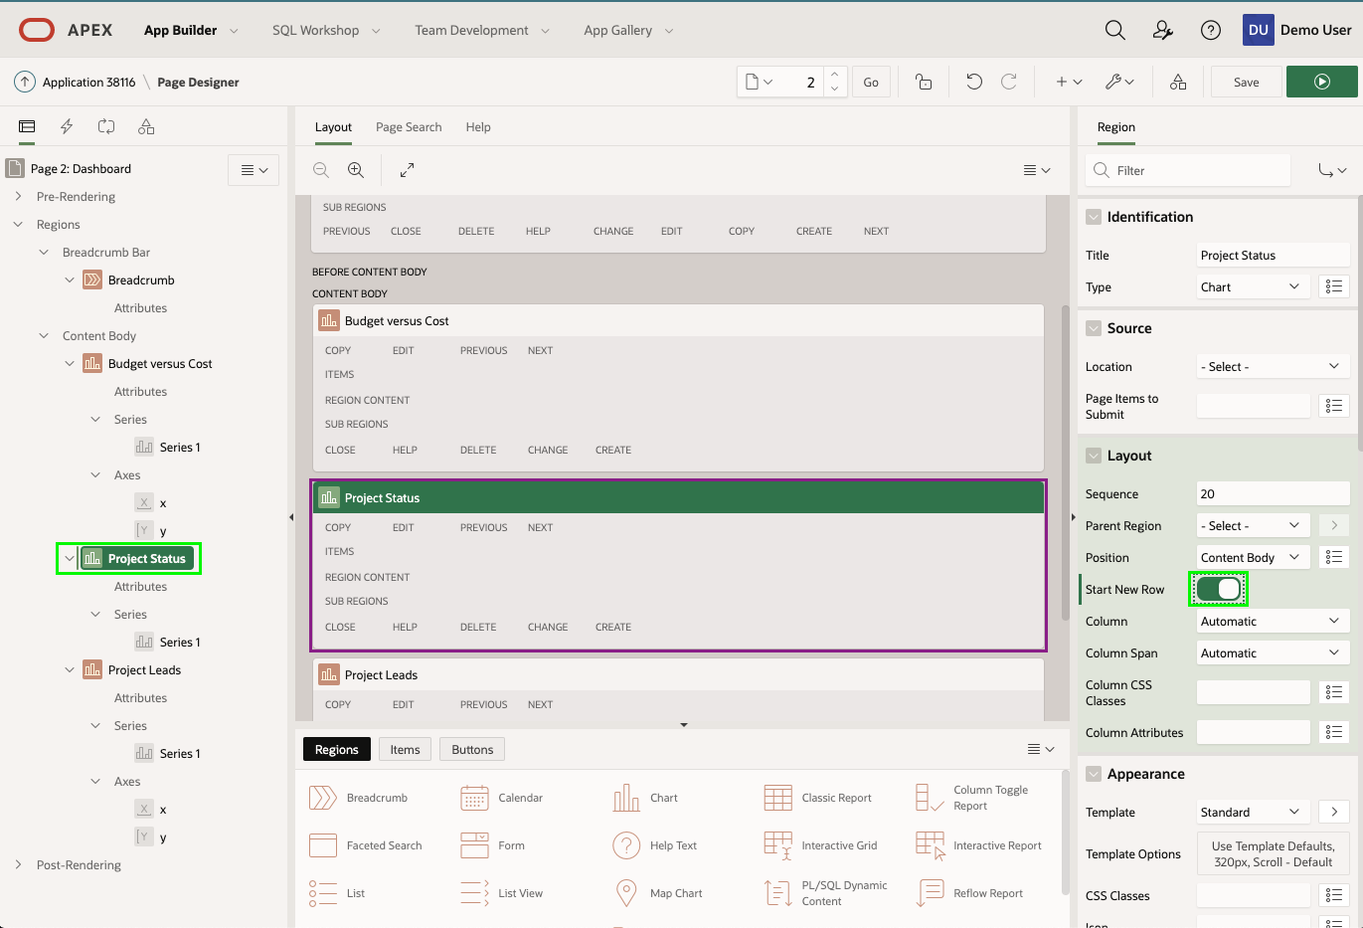

1. Now to move the Project Leads chart up on to the same line as the Project Status chart.  
   In the Rendering tree (left pane), click **Project Leads**.  
   In the Property Editor (right pane), ***uncheck*** **Layout > Start New Row**.  
   *Note: Within Layout (middle pane), the Project Leads region will move up to be on the same row as Project Status*

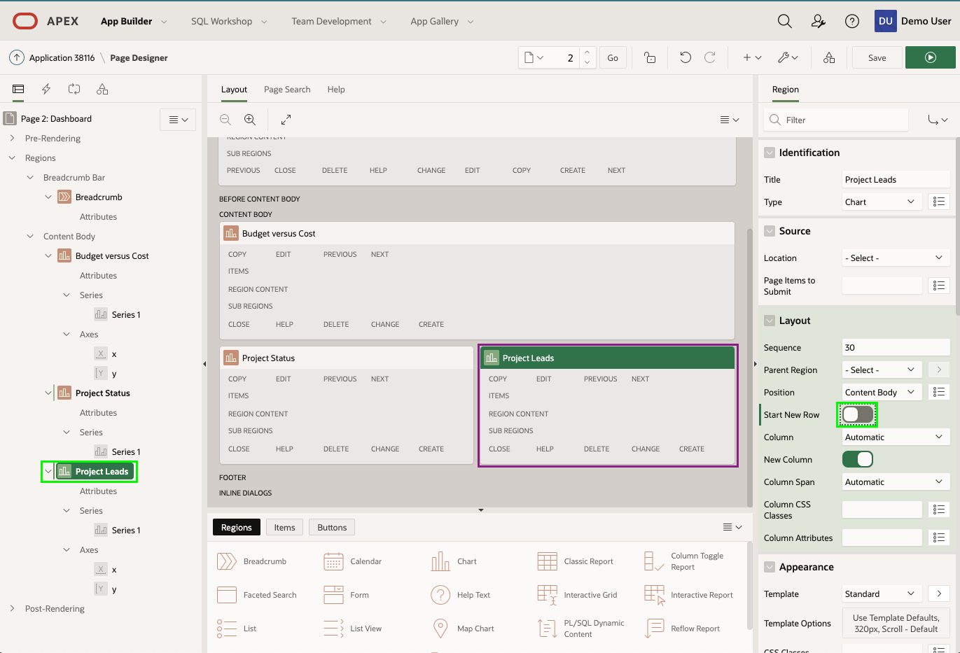

1. Now to review the page!  
   Click **Save and Run Page** button.

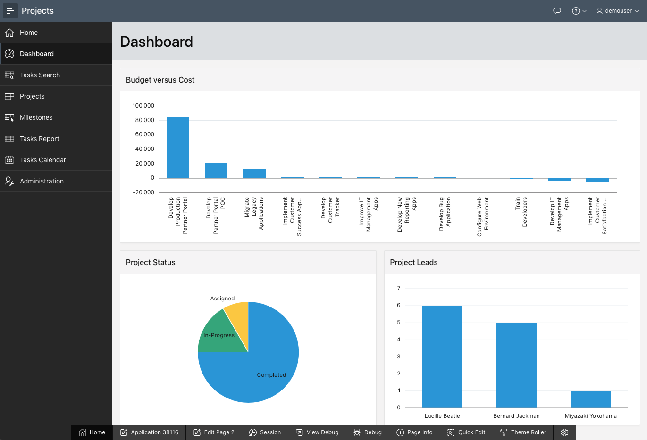

**Summary**

This completes Lab 4. You now know how to remove and reposition regions.

# Improving Projects

**Introduction**

In this lab, you will learn how to use the *Create Page Wizard* to add additional pages to your app. Then, you will link the new page to the existing Card page. You will then learn how to easily manipulate how items are displayed, and finally to create a *Dynamic Action*.

Collapse All Tasks

**Task 1: Changing the Cards Region Style**

Looking at the Projects Card region, you should notice the cards' icons are circle, which could be displayed differently. To change the cards region style, you will utilize **Live Template Options** directly in the runtime environment. You could also make changes from the App Builder; however, it is much easier to make changes as you can see the results.

1. In the runtime environment, click **Projects**.
2. In the Developer Toolbar (at the bottom of the runtime environment), click **Quick Edit**.

Move the mouse until it is inside the Cards region, and a blue box surrounds the region, with a wrench in the top right corner.  
Click the wrench.

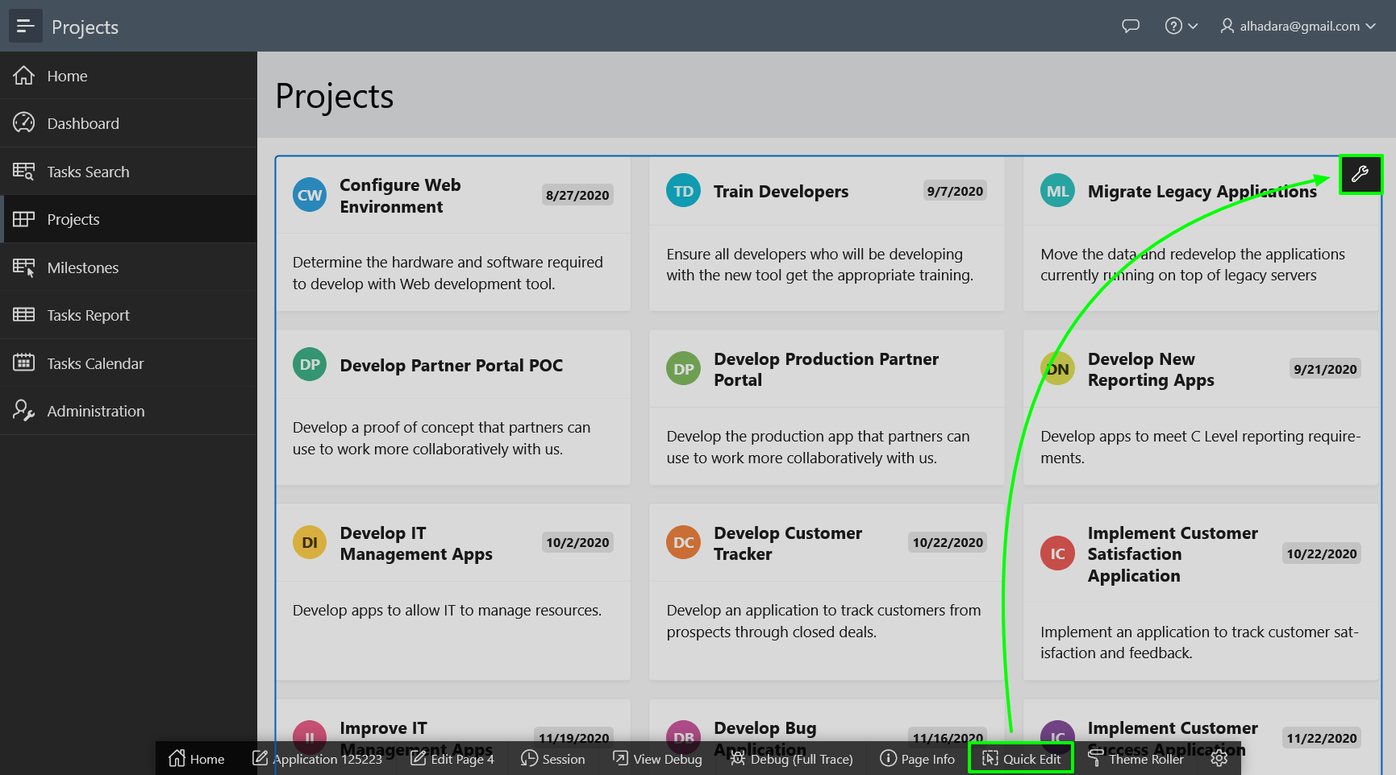

1. In the Live Template Options dialog, select the following:
   * Style - select **Style A**
2. Click **Save**

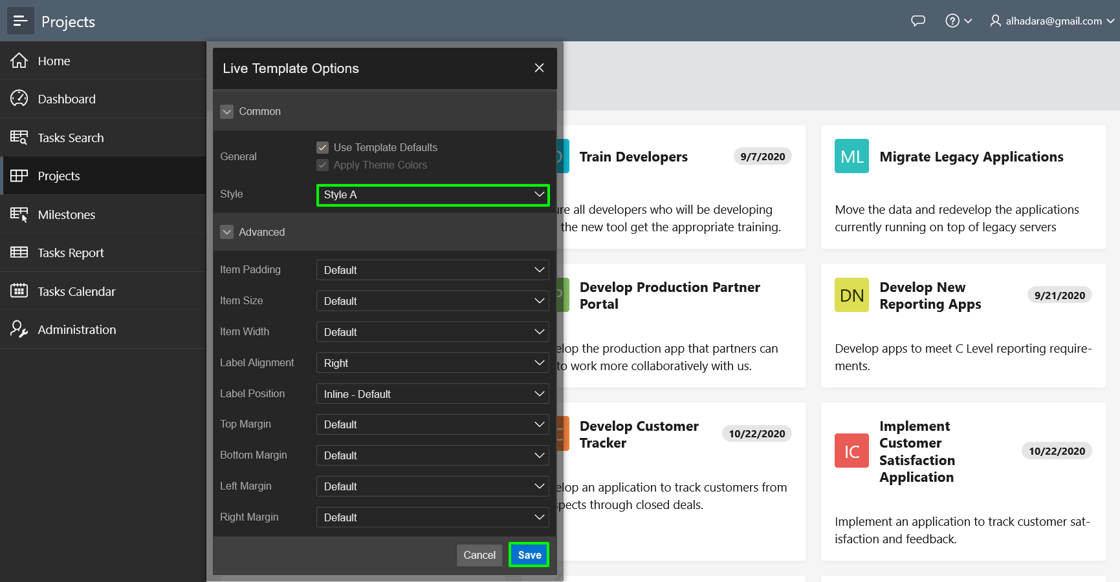

**Task 2: Enhancing Projects Page**

You will notice that the Projects page shows the cards columns based on the current available width. Let's fix the number of grid columns to 4. We will also add the project lead in the subtitle of the card.

1. In the Developer Toolbar (at the bottom of the runtime environment), click **Edit Page 4**.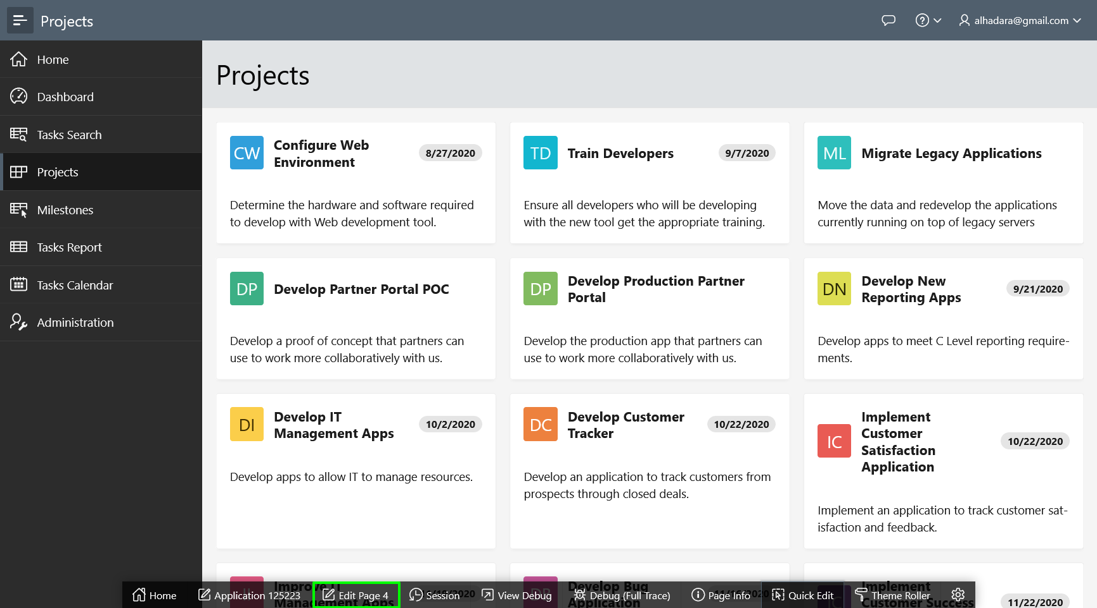
2. In the Property Editor (the right pane), under Attributes tab, change the followings:
   * Grid Columns to **4 Columns**
   * Subtitle Column to **PROJECT_LEAD**
   * Click the **Save and Run Page** button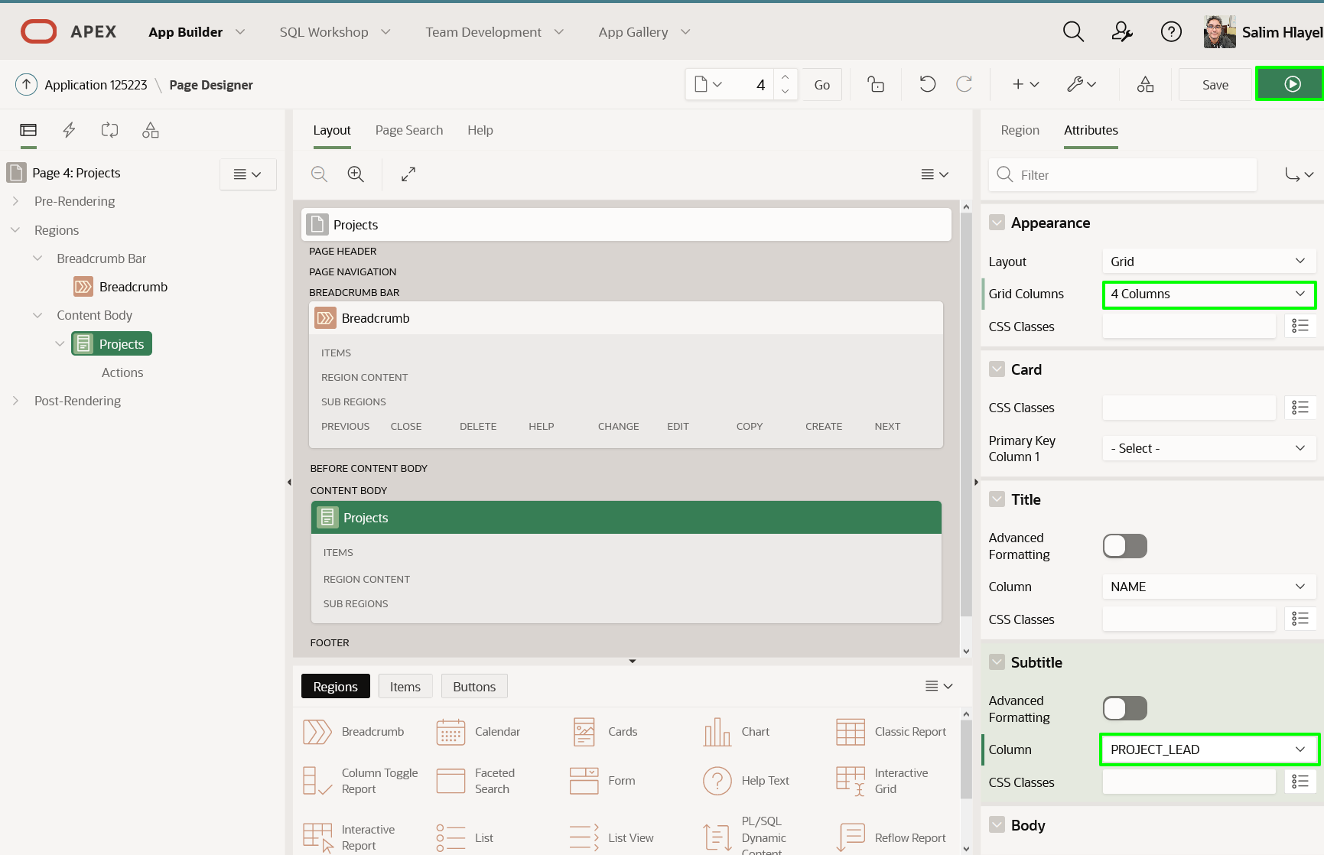
3. The Cards Region now show only four projects per row. The Project Lead is added in the subtitle of the card.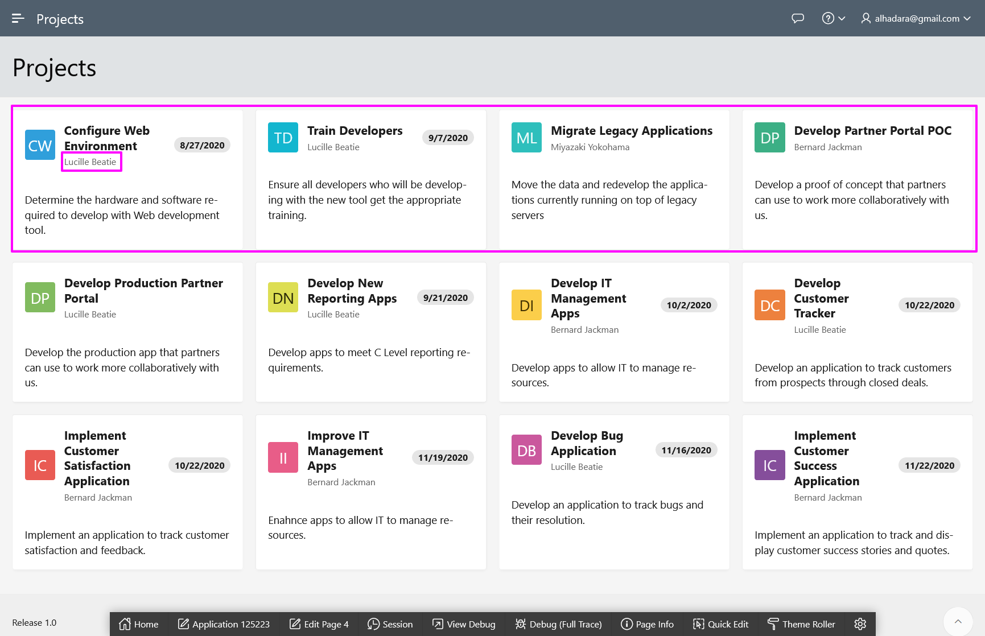

**Task 3: Adding a Form Page**

Currently there is no way to maintain project records. Therefore, you will use the *Create Page Wizard* to create a form page on the *EBA_PROJECTS* table.

1. Navigate back to the App Builder by clicking **Application xxxxx** in the Developer Toolbar, or by navigating back to the App Builder browser tab manually.
2. On the application home page, click **Create Page**.

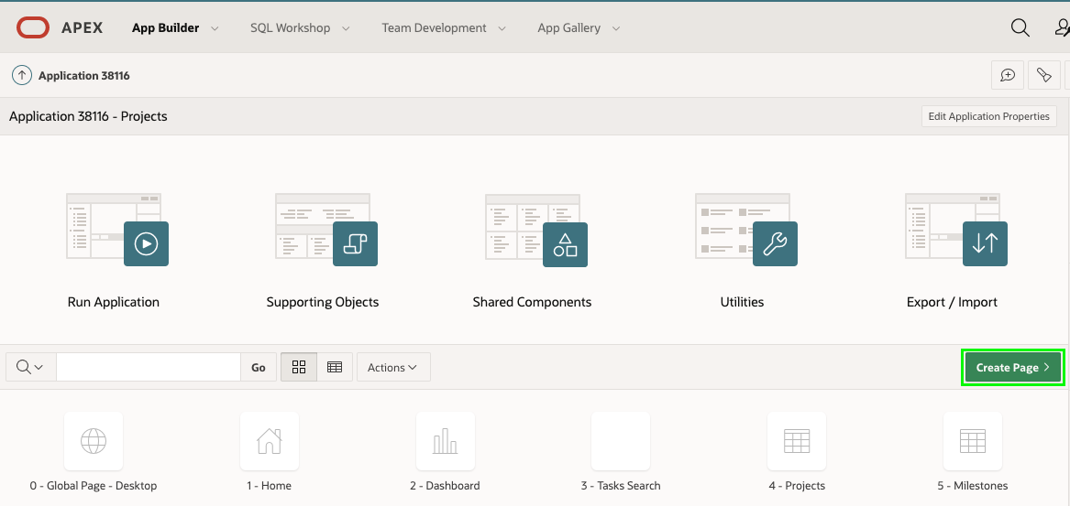

1. In the Create a Page dialog, click **Form**.

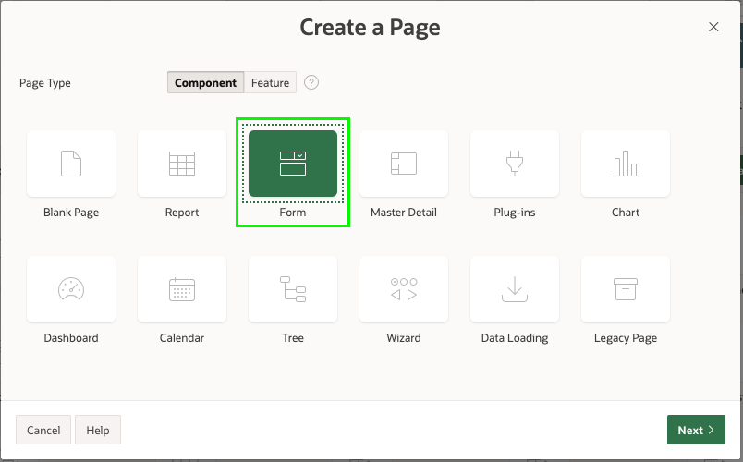

1. In the Create Page dialog, click **Form**.

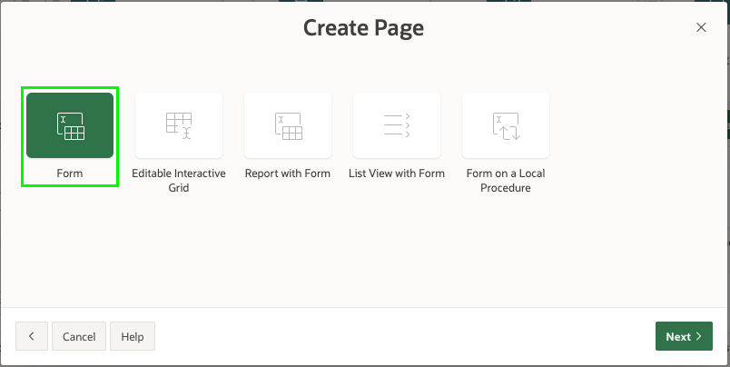

1. In the Create Form dialog, for Page Attributes, enter the following:
   * Page Name – enter **Project**
   * Page Mode – click **Modal Dialog**

Click **Next**

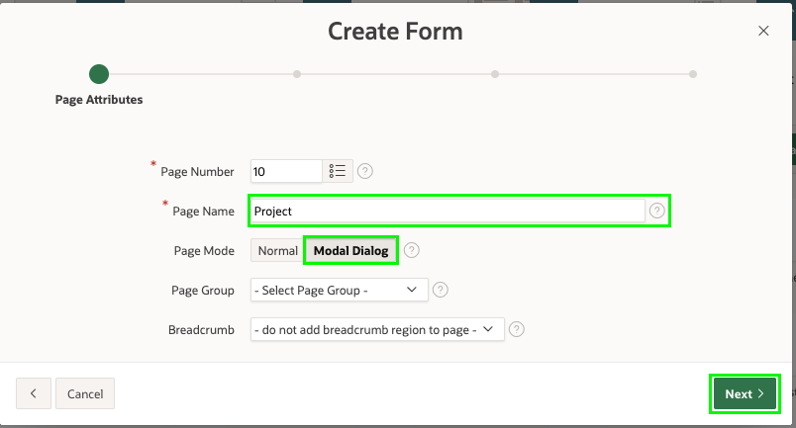

1. For Navigation Menu, select **Identify an existing navigation menu entry for this page**. For Existing Navigation Menu Entry, select **Projects**.  
   Click **Next**.

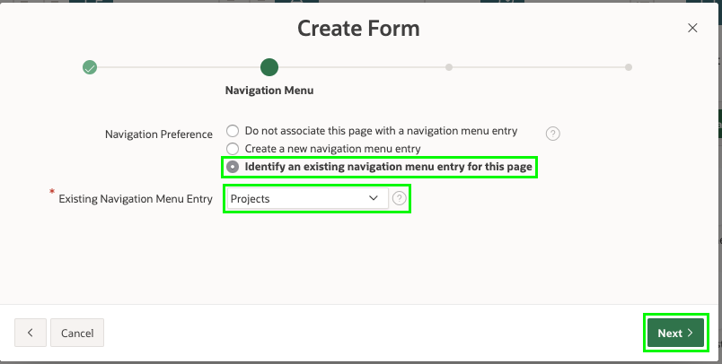

1. For Table/ View Name, select **EBA_PROJECTS (table)**.  
   Click **Next**.

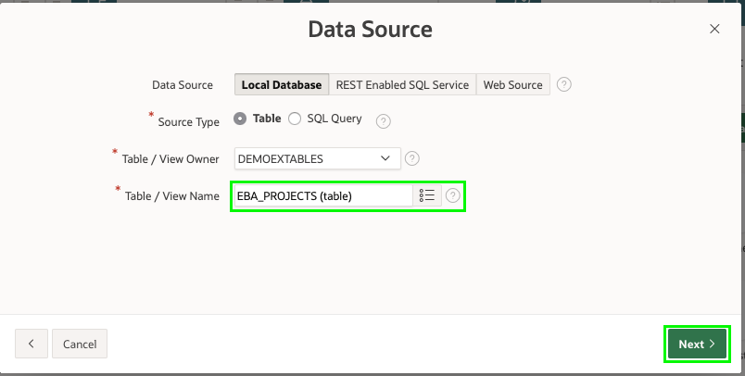

1. For Primary Key Column, select **ID (Number)**.  
   Click **Create**.

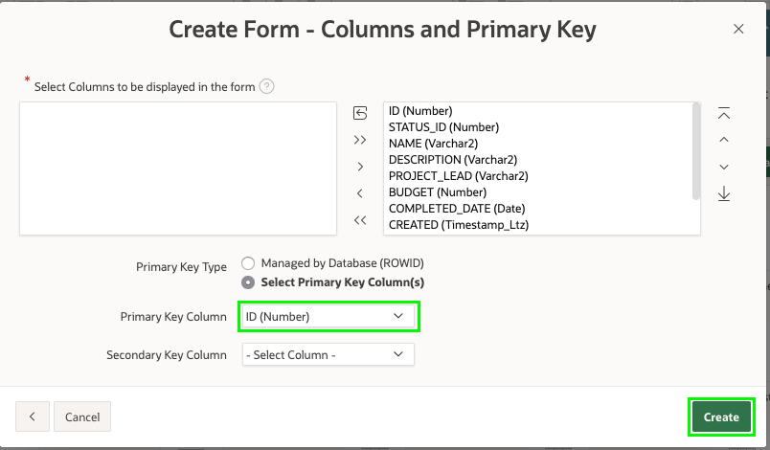*Note: This will create Page 10: Project if you have followed the previous sections correctly. If not Page 10, please repeat Lab 3, and ensure the Interactive Grids for both Milestones and Statuses are created*

**Task 4: Link to Projects Page**

Now to link this new page to the Project Cards page.  
*Note: Defining a link for a Card region requires modifying the SQL statement. However, elsewhere in Oracle APEX, defining links is very easy and declarative as you will learn in Lab 7.*

1. In the Application Toolbar, click the page selector in front of the page number (10).  
   Click **4**, for the Projects page

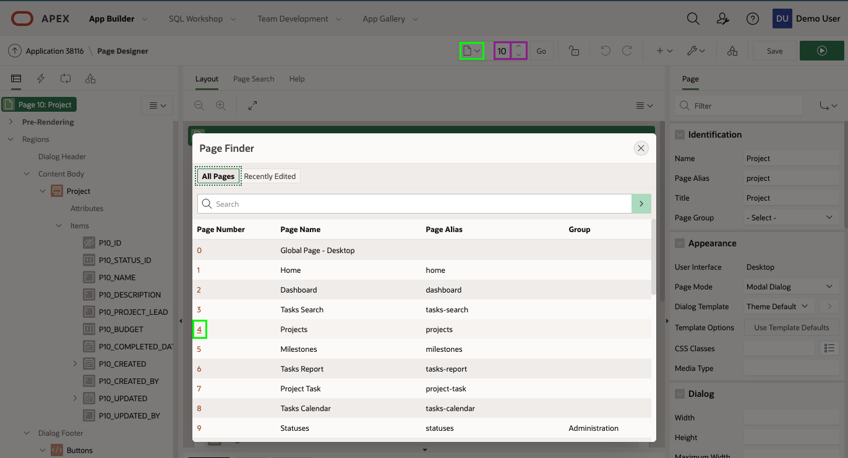

*Note: Alternatively, you can type in a page number or use the up / down arrows in the Application Toolbar to navigate to different pages within Page Designer*

1. In the Rendering tree (left pane), right click **Actions** under **Projects** then click **Create Action**.

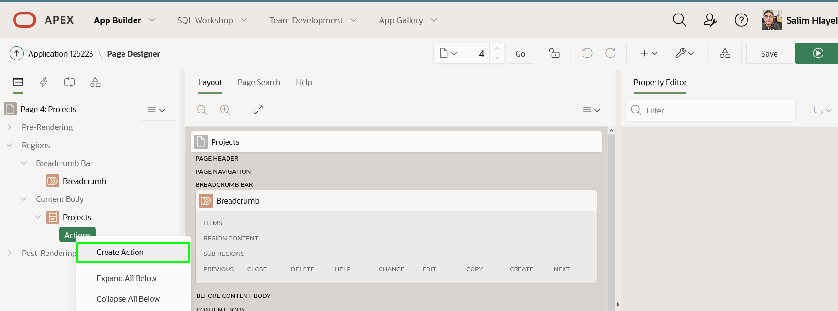

In the Property Editor (right pane), update the following properties:

* + **Type:** - select Full Card
  + Click **Link > Target**
  + In the Link Builder, **Page** - enter **10**
  + Under **Set Items**, Enter **P10_ID** for **Name** and enter **&ID.** for **Value**

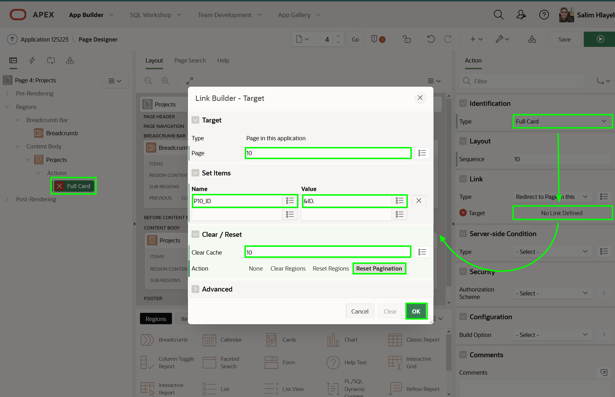

1. You also need to be able to add new projects, so will need to add a button and link it to the Project form page. The easiest way to add this is to drag and drop a component into the Layout (middle pane) from the Gallery.
   * In the Layout (middle pane), click **Breadcrumb** to highlight the region.
   * In the Gallery (below Layout), click **Buttons**.
   * Click and hold **Text [Hot]**.
   * Drag the button up into the Breadcrumb region, and hover under the **Create** placeholder.

Once the CREATE selection expands to a large yellow box, release the mouse.

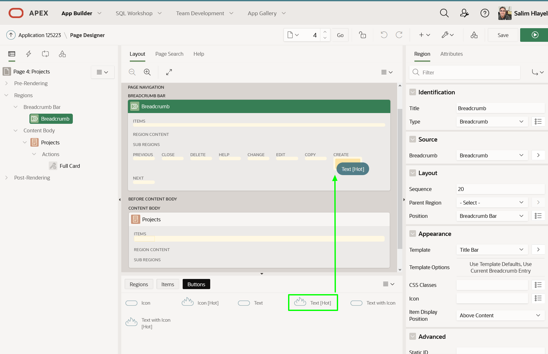

1. Now to update the button properties.  
   In the Property Editor (right pane), enter the following:
   * Identification > Button Name - enter **CREATE**  
     *Note: The Identification > Label is update to Create once you enter the Button Name*
   * Behavior > Action - select **Redirect to Page in this Application**
   * Behavior > Target - click **No Link Defined**, and enter:
     + Target > Page - enter **10**
     + Clear / Reset > Clear Cache - enter **10**
2. Click **OK**

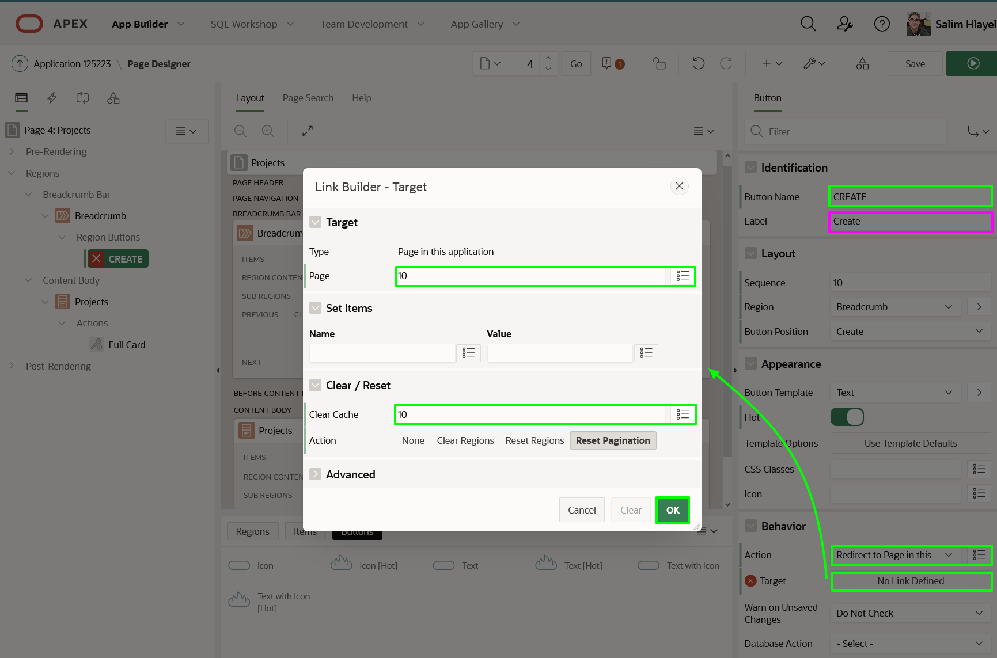

1. Now to test the page links work!  
   Click **Save and Run Page** button. Click on a project card or click **Create**.

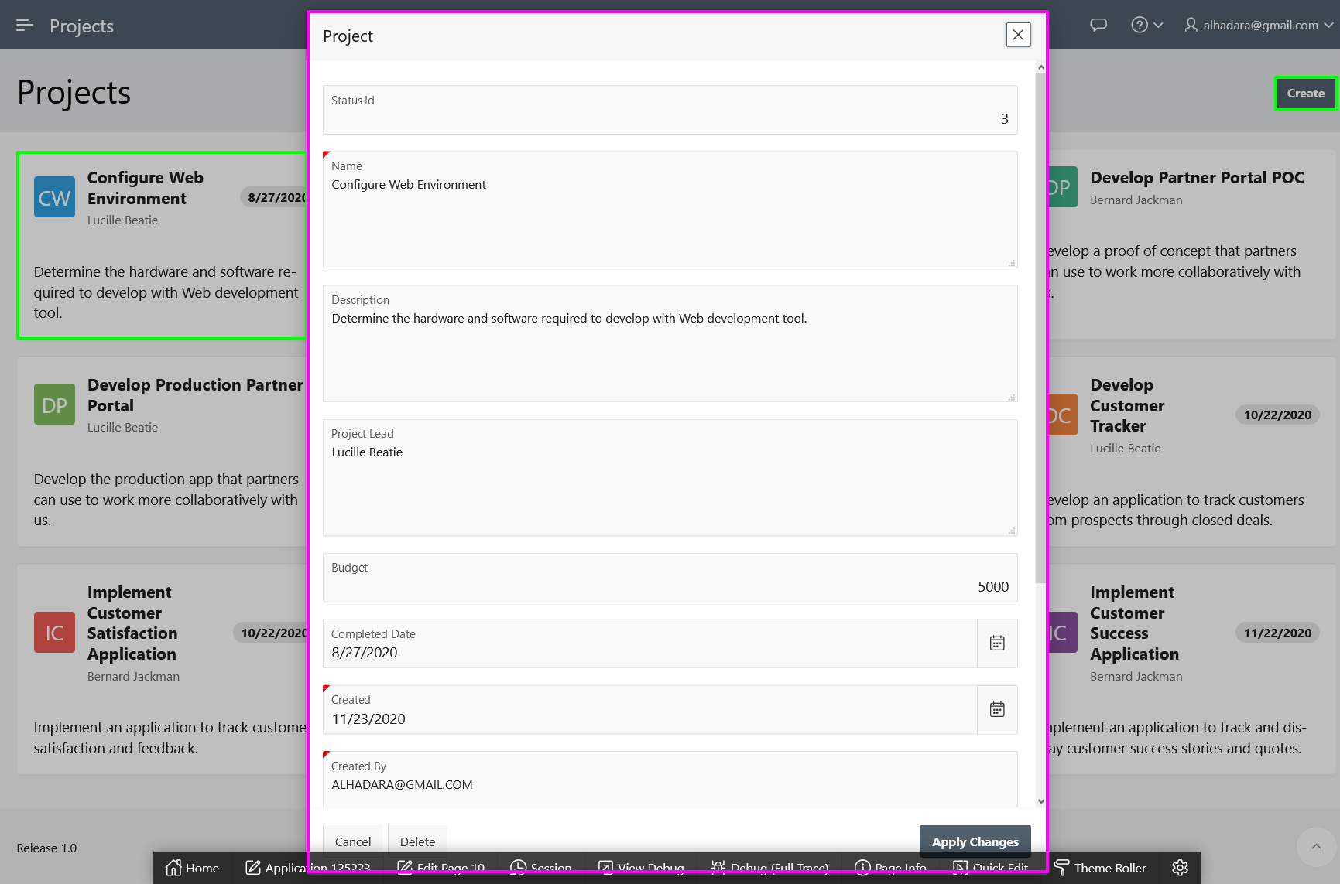

**Task 5: Update How Items are Displayed**

The way the Status Id, Name, and Project Lead are displayed can be easily improved. The **Status Id** item is a foreign key to the **EBA_PROJECT_STATUS** table. Therefore, rather than requiring end users to enter a number, you will update the item to be a list of values based on the lookup table. The Name and Project Lead fields should be updated to Text Fields. Lastly, the audit columns (Created, Created By, Updated, Updated by) should be hidden.

1. First you need to change the Status item from a number entry to a list of allowable values.  
   From the Runtime environment, from the Project Form page, in the Developer Toolbar, click **Edit Page 10**.  
   Alternatively, navigate back to the App Builder browser tab, and then navigate to Page 10 manually.
2. In Page Designer for Page 10, in the Rendering tree (left pane), click **P10_STATUS_ID**.  
   In the Property Editor (right pane), enter the following:
   * Identification > Type - select **Select List**  
     *Note: As soon as you choose Select List, P10_STATUS_ID item will change to red and a Message indicator will display in the Application Toolbar. This will be remedied once the List of Values attributes are entered*
   * Label > Label - enter **Status**
   * List of Values > Type - select **SQL Query**
   * SQL Query enter:
   * Copy**select** code d, id r
   * **from** eba_project_status

**order** **by** display_order

1. *Note: The code column is the value displayed to users, while the id column is the value returned to the table column. The table includes a display_order column to ensure the statuses are displayed in the correct order*
   * Display Extra Values - **Uncheck**
   * Null Display Value - enter **– Select Status -**  
     *Note: This text must be typed*

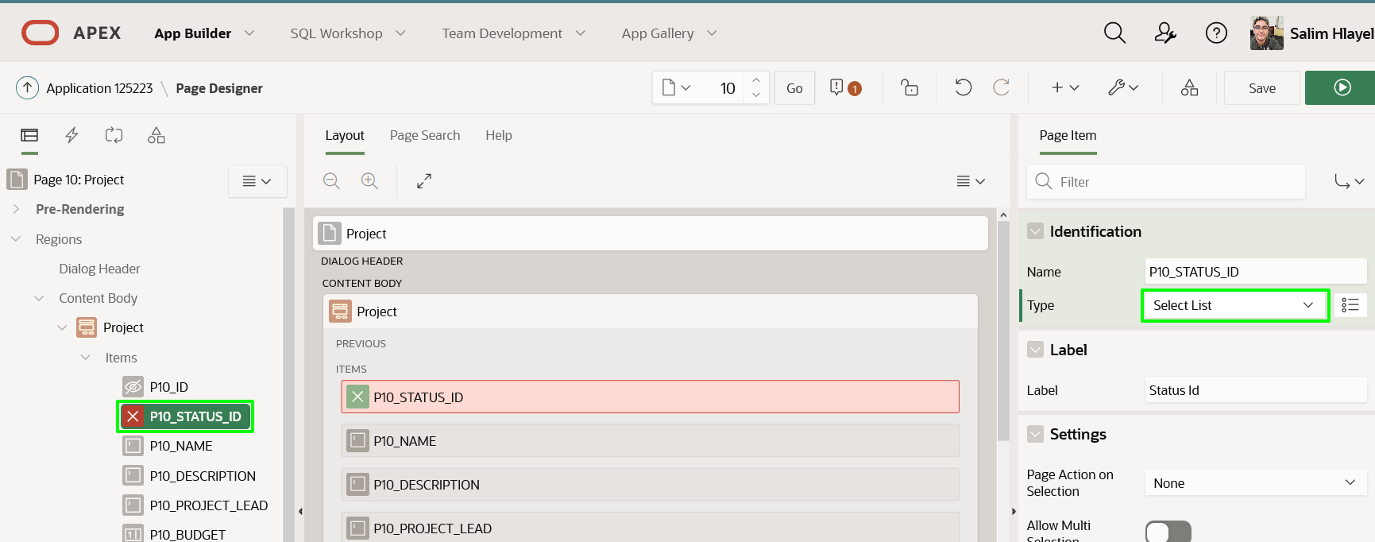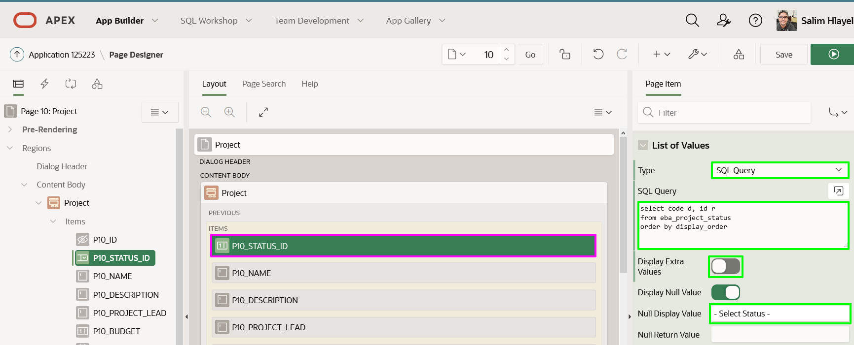

1. Now to update the Name and Project Lead items to text fields.  
   In the Rendering Tree (left pane), click **P10_NAME**  
   Hold down the [Control] key (or [Command] key in Mac) and click **P10_PROJECT_LEAD**

In the Property Editor (right pane), for Identification > Type, select **Text Field**

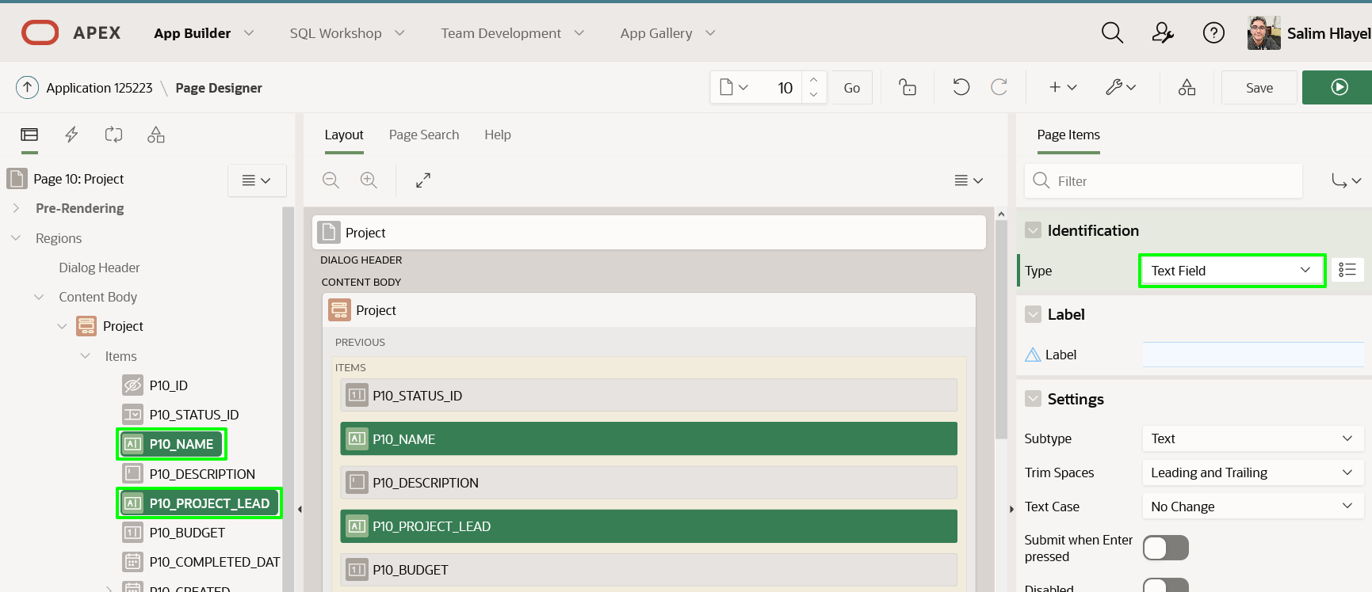

1. Last step is to hide the audit columns.  
   In the Rendering Tree (left pane), click **P10_CREATED**  
   Hold down the [Shift] key and click **P10_UPDATED_BY**

In the Property Editor (right pane), for Identification > Type, select **Hidden**

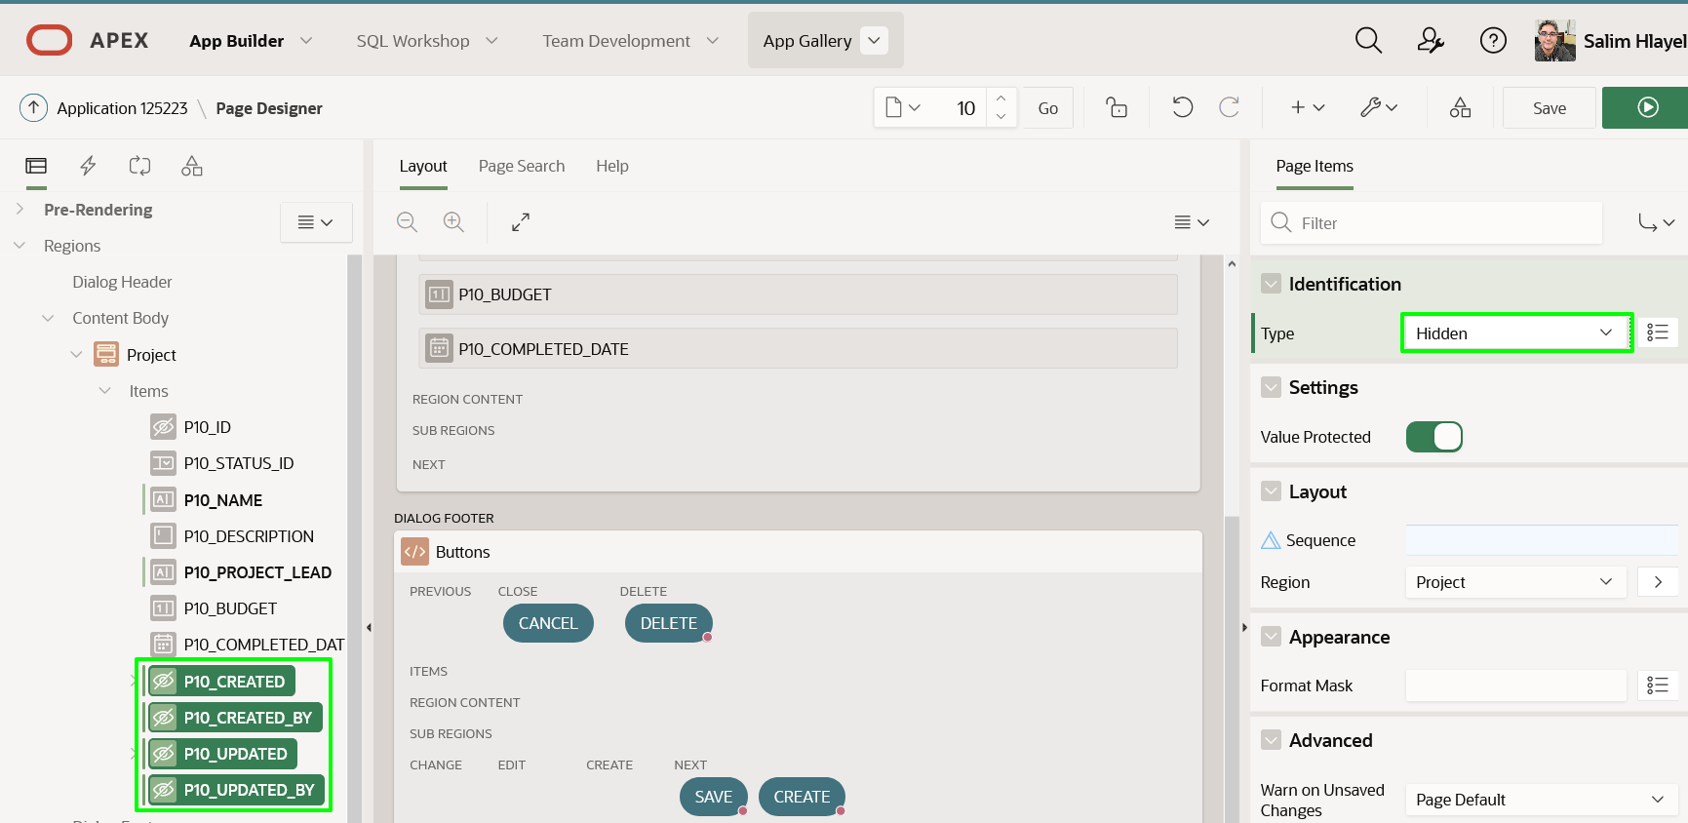

**Task 6: Improve the Completed Date**

Currently a Completed Date can be entered on any project. However, it would greatly improve data quality to allow the completed date to be entered only if the Status is *COMPLETED*. Implementing such functionality requires JavaScript to dynamically enable / disable the Completed Date item based on the value of Status. Thankfully, as an APEX developer, you don't need to write such JavaScript. You can simply define a *Dynamic Action*, which allows you to declaratively define such client-side interactivity, by specifying the trigger, action, and affected element(s).

1. You need to define the Dynamic Action on the triggering element, which is the Status.  
   In the Rendering Tree (left pane), *right-click* **P10_STATUS_ID**.  
   Select **Create Dynamic Action**.

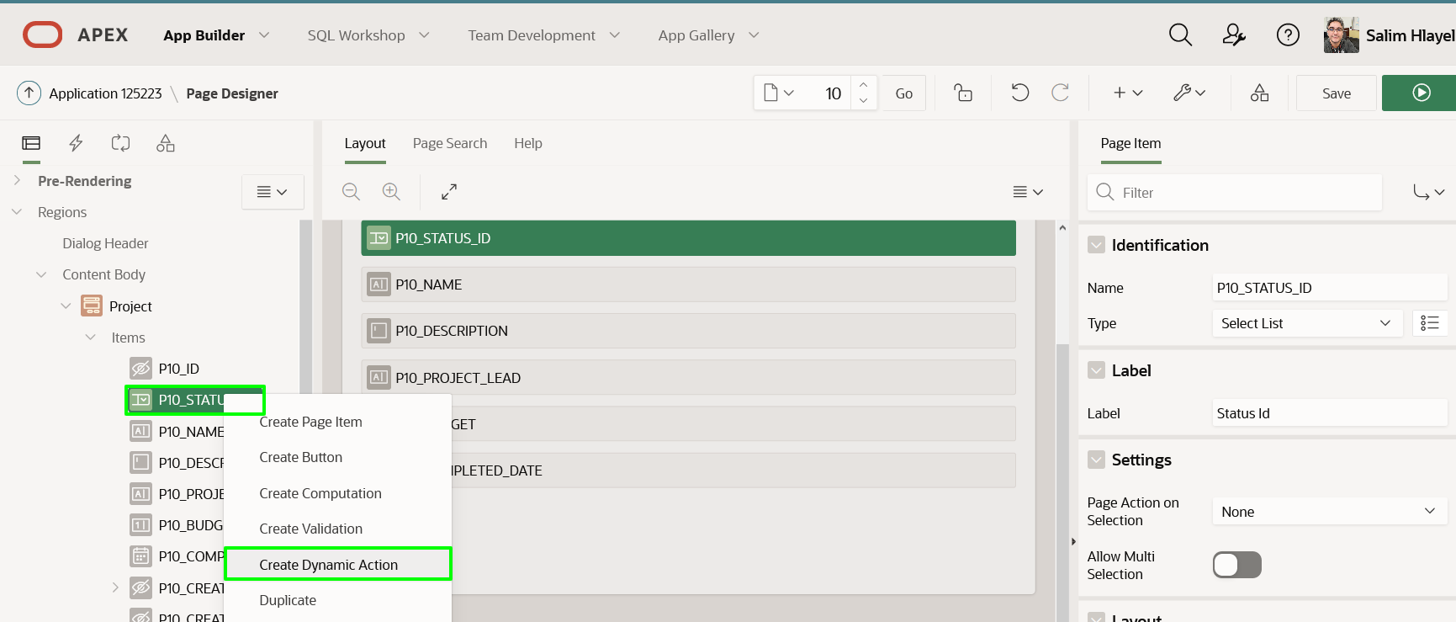

1. Update the Dynamic Action so that it only trigger when the Status is *COMPLETED*.  
   With the Dynamic Actions selected (click **New** under Dynamic Actions), in the Property Editor (right pane), enter the following:
   * Identification > Name - enter **Enable Completed Date**
   * Client-side Condition > Type - select **Item = Value**  
     *Note: The Client-side Condition > Item is automatically set to the current item P10_STATUS_ID*
   * Client-side Condition > Value - enter **3**  
     *Note: The value 3 corresponds to a status of COMPLETED*

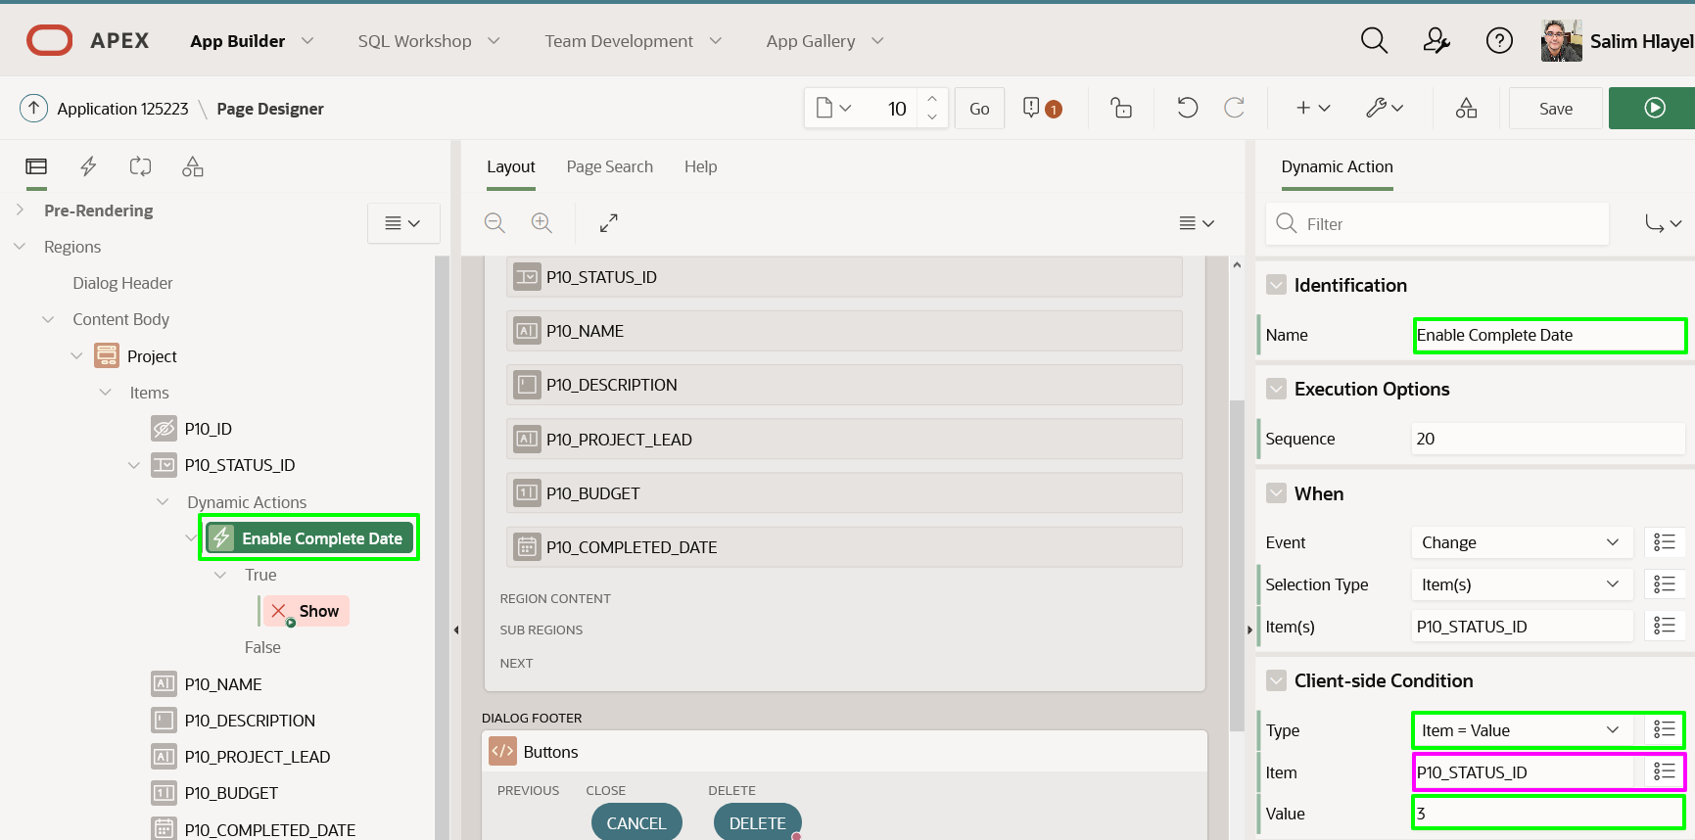

1. Next you need to specify what happens when the triggering event is true.  
   In the Rendering tree (left pane), click the action under True (currently Show).  
   In the Property Editor (right pane), enter the following:
   * Identification > Action - select **Enable** (under **Component**)
   * Affected Elements > Item(s) - select **P10_COMPLETED_DATE**

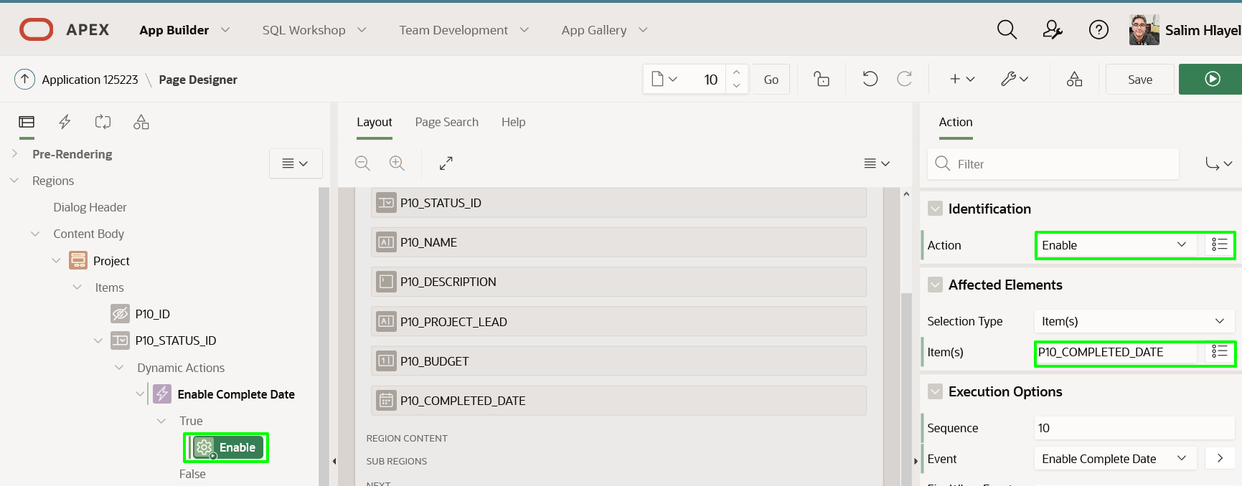

1. Lastly, it is very important to *disable* the Completed Date item when the triggering event is false.  
   In the Rendering tree (left pane), under Dynamic Actions, *right-click* **Enable**.  
   Select **Create Opposite Action**.

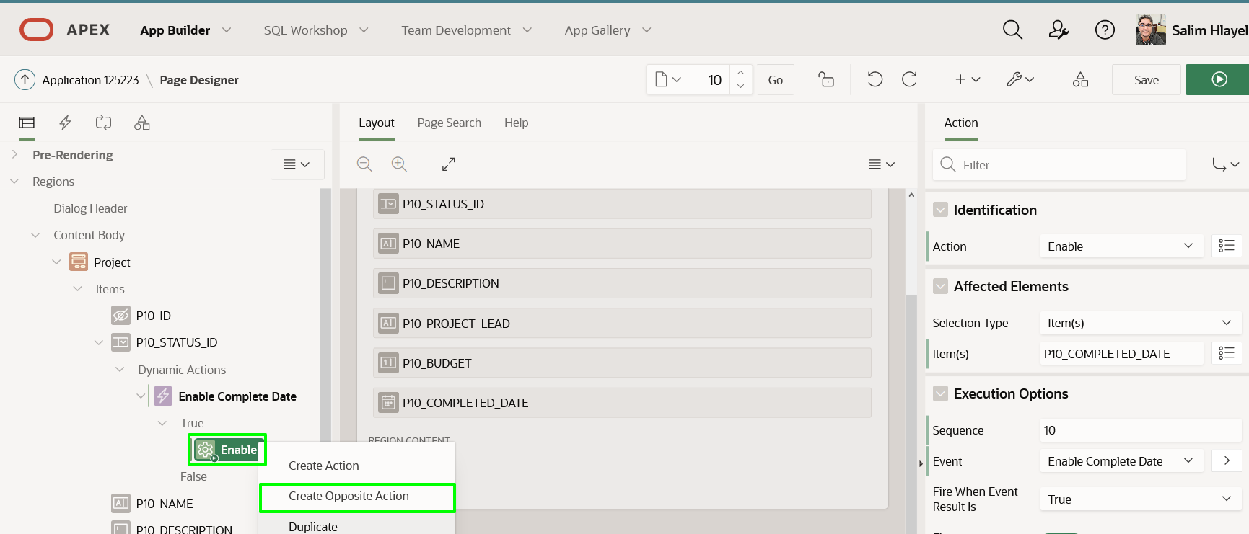

1. Rather than displaying the Completed Date down the page, it would be far better to display the item directly after the Status item.  
   In the Rendering tree (left pane), click **P10_COMPLETED_DATE**.  
   In the Property Editor (right pane), enter the following:
   * Layout > Sequence - enter **50**  
     *Note: This will position P10_COMPLETED_DATE between P10_STATUS_ID (Sequence 40) and P10_NAME (Sequence 60)*
   * Layout > Start New Row - *Uncheck*  
     *Note: This will position the item on the same line as the previous item, P10_STATUS_ID*

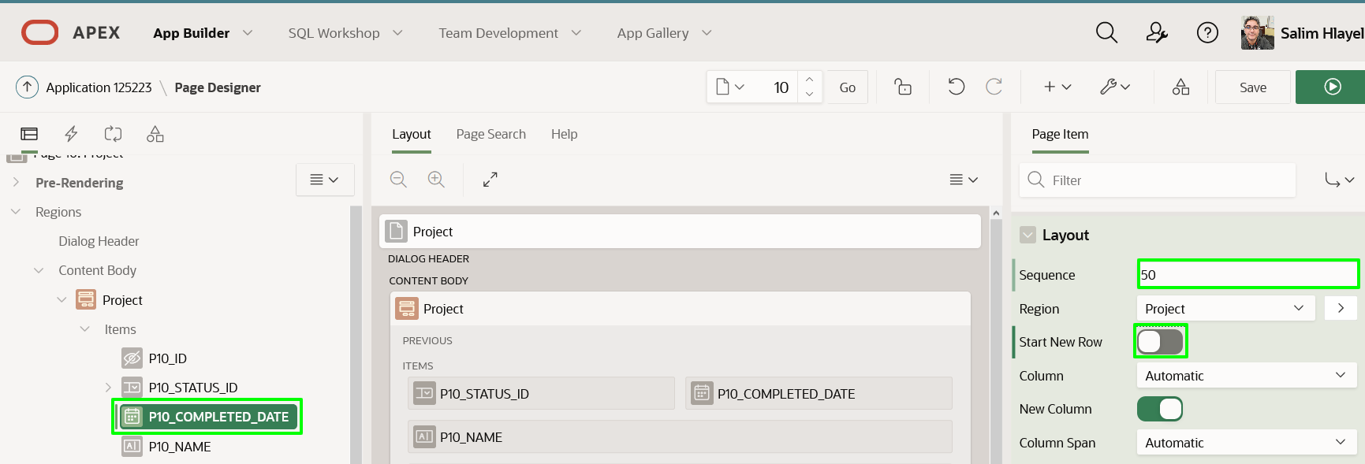

1. Now to review the Project Form page.  
   Click **Save**  
   *Note: If you click the Save and Run Page button, your changes will be saved but the page will not be run. Given the Project Form page is a modal page, it must be run from a calling page, rather than directly from Page Designer*
2. Navigate back to the Runtime environment, refresh the browser, and within the Navigation Menu (left side) click **Projects**.  
   Click a card record to display the corresponding record in the form page.  
   Change the Status and ensure the Completed Date is enabled / disabled correctly.  
   Make changes and click **Apply Changes**, or click **Cancel**.

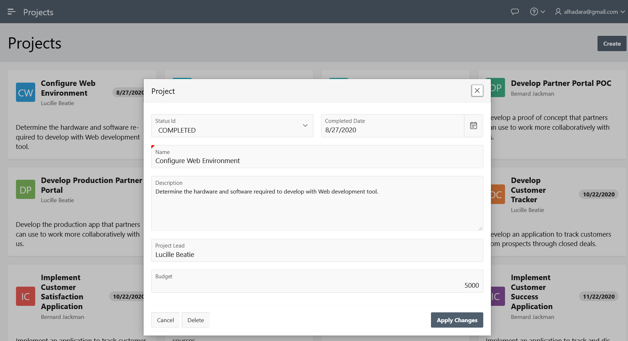

**Summary**

This completes Lab 5. You now know how to add additional pages to your application, link pages together, modify how items are displayed, and define client-side interactivity declaratively.

# Improving Milestones

**Introduction**

In this lab, you will learn how to update and then save the layout of an *Interactive Grid* to improve your Milestones.

Collapse All Tasks

**Task 1: Change the Name Column**

In your runtime environment, click on **Milestones** and then double-click a record, you can edit the details. Navigate to each column and notice that the Project column is a select list, the Name and Description columns are textareas, and the Due Date is a date picker. Generally, the Name is not that long; therefore, you should update the column type to a text field.

1. Navigate to the App Builder.
2. Within your application, navigate to **Page 5: Milestones** in Page Designer.
3. In the Rendering tree (left pane), under the **Project Milestones** region, expand **Columns**.  
   Within the list of columns click **Name**.  
   In the Property Editor (right pane), for Identification > Type select **Text Field**.

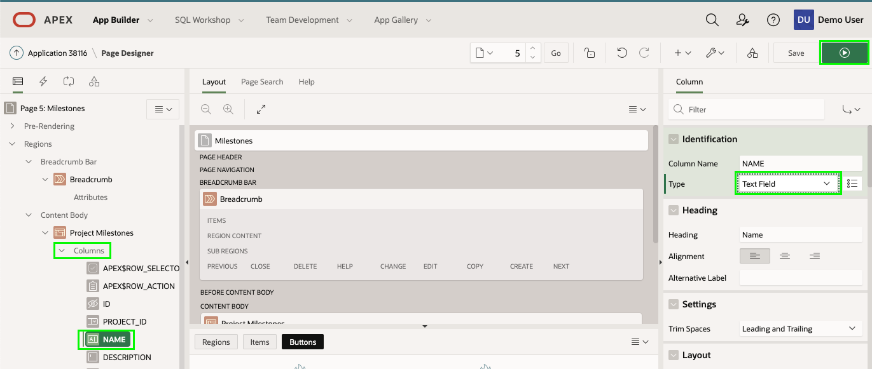

1. In the Application toolbar, click **Save and Run Page**  
   Double-click a record and review the Name column.

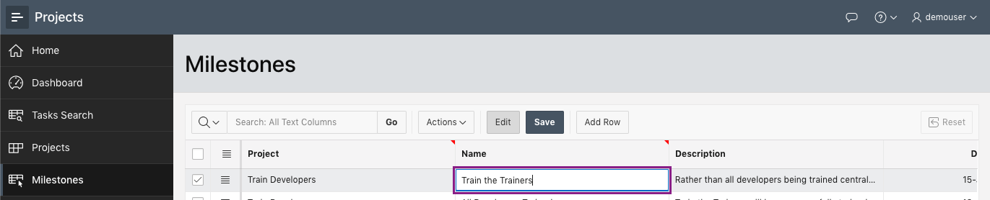

**Task 2: Update the Grid Layout**

Once again reviewing the report, it would be beneficial to rearrange the columns into the following order - Name, Project, Due Date, and then Description. It would also be useful to freeze the Name column so users can scroll left and right to see more of the Description column.

1. In the Runtime environment, click **Actions**, and then click **Columns**

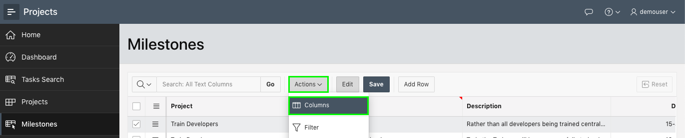

1. In the Columns dialog, click **Name** and then click the up arrow to move the column before **Project**.  
   Click **Save**.

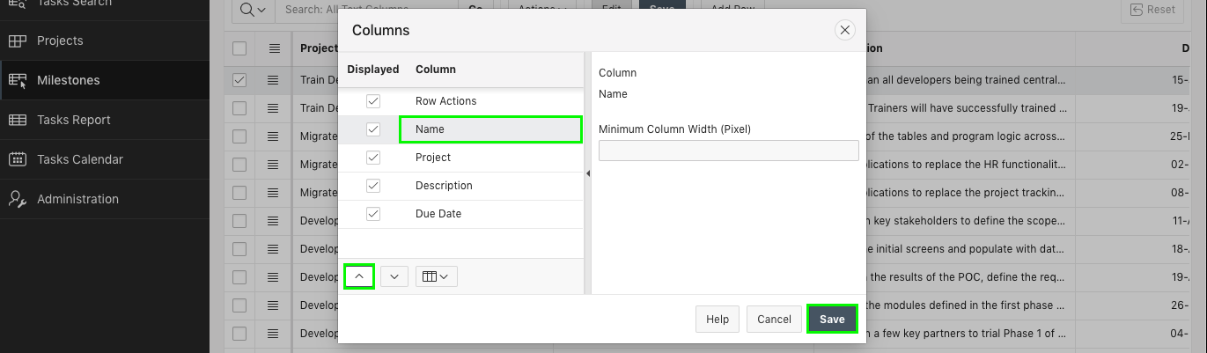

1. You can also reorder columns using Drag and Drop.
   * Hover over the beginning of the **Due Date** column until the movement indicator is displayed.
   * Click and hold the mouse.
   * Drag the column to the left until it displays before the **Description** column.
   * Release the mouse, dropping the column.

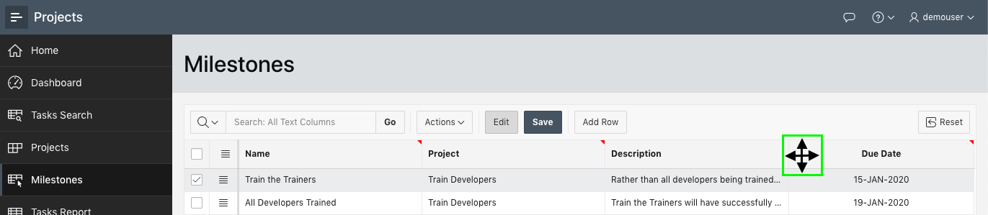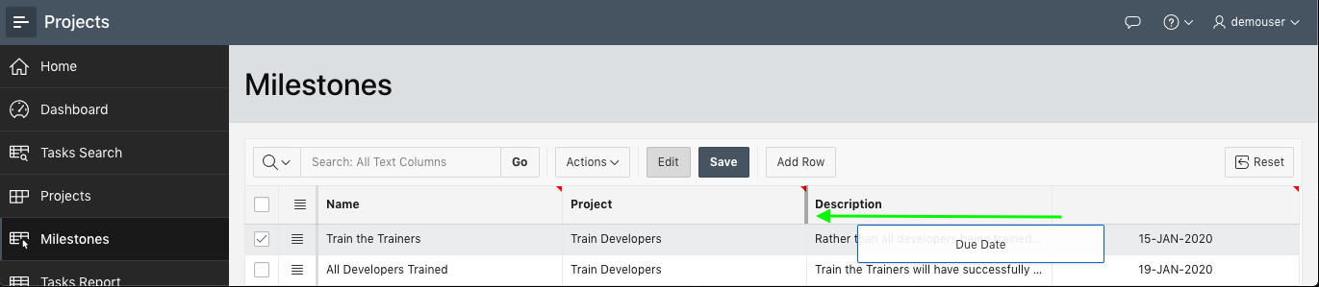

1. To see the grid better, you can collapse the menu.  
   Click the icon in front of the application name.

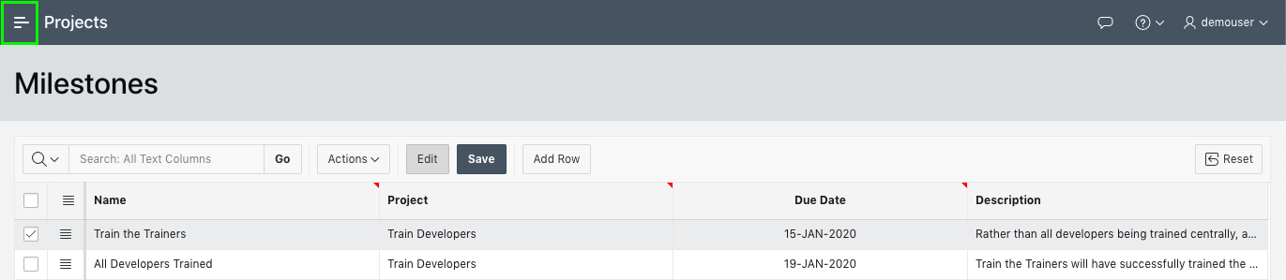

1. Now that the columns are in the correct order, you should freeze the Name column.
   * Click the **Name** column heading.
   * Click **Freeze**.

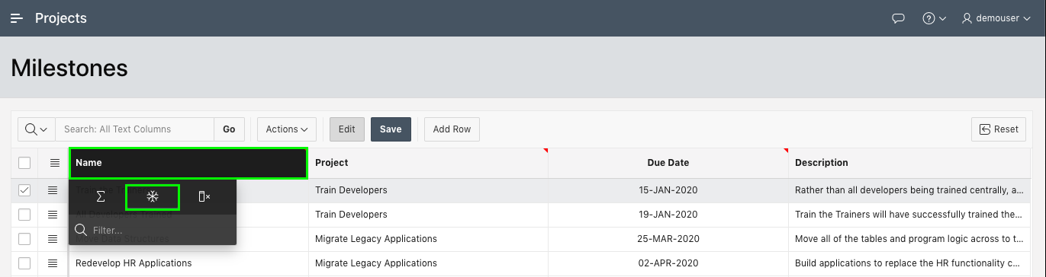

1. The column sizes now need to be adjusted to better display the data.
   * Hover in between the **Name** and **Project** columns until the resize indicator is displayed.
   * Drag the column separator to the right until it is a good size for the **Name** column.
   * Repeat for the Project and Due Date columns.  
     *Note: You can also expand the size of the Description column by using the resize indicator at the end of the column*

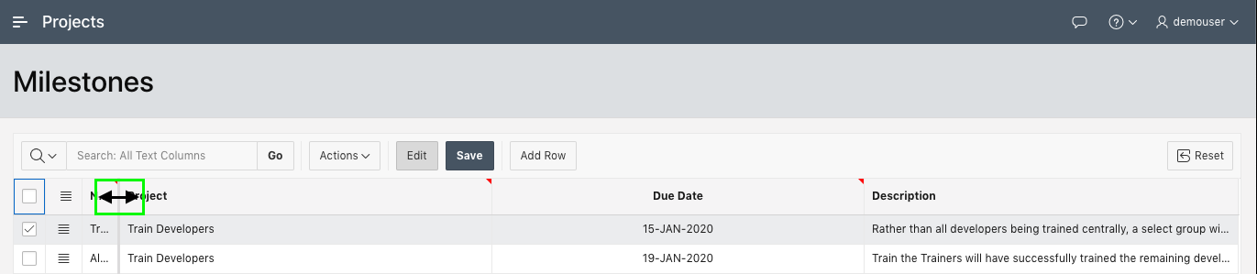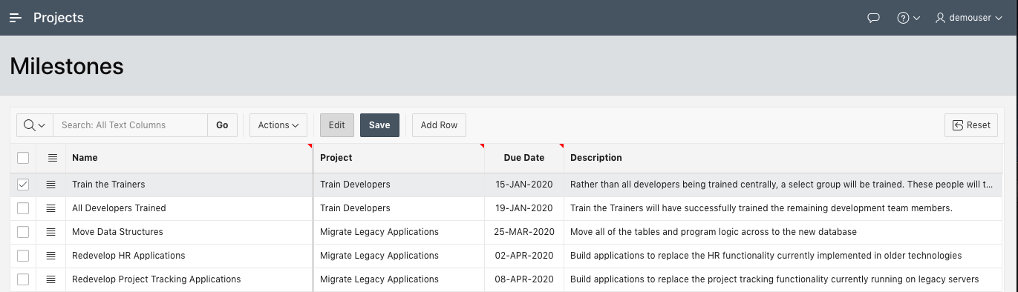

1. To test the freeze display, redisplay the menu. Click the icon in front of the application name.

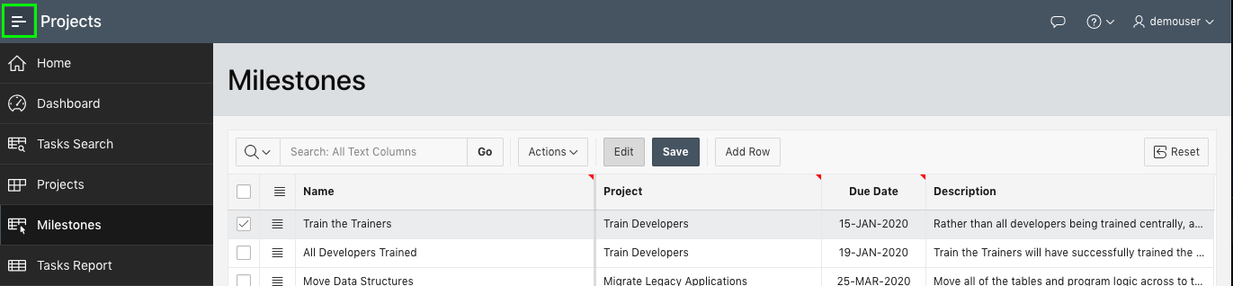

**Task 3: Save the Report**

The changes you have made to the grid layout are only visible to you. If other users log in, they will see the original layout with the previous column order and column sizes. Therefore, you need to save the Default report layout.

1. In the runtime environment, click **Actions**, select **Report**, and then select **Save**.  
   *Note: Only developers, who have run the application from App Builder, can save the "Default" report. End users can only use "Save As"*

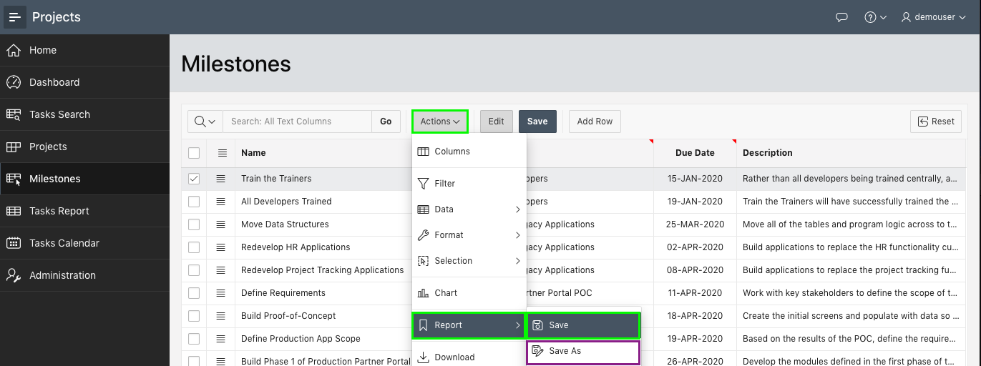

**Summary**

This completes Lab 6. You now know how to manipulate an Interactive Grid and save a default report.

# Improving Tasks

**Introduction**

In this lab, you will learn how to define a shared *List of Values* and use it to improve the Faceted Searches and Interactive Report pages for Tasks. You will also learn how easy it is to link the Calendar to the Tasks Form page.

Collapse All Tasks

**Task 1: Defining a Shared List of Values**

In the Runtime environment, navigate to **Tasks Search** and review the page. Notice that Is Complete column simply displays "Y" or "N". Now navigate to **Tasks Report**, and you will notice the same issue. It would be far better to display "Yes" or "No". This can readily be achieved by defining a *List of Values (LOV)*

You can define a LOV directly on a page. However, if you require the same LOV on multiple pages, as you do here, it is far better to define it once as a *Shared Component*.

1. Navigate back to the App Builder browser tab, click your application.
2. On the application home page, click **Shared Components**.

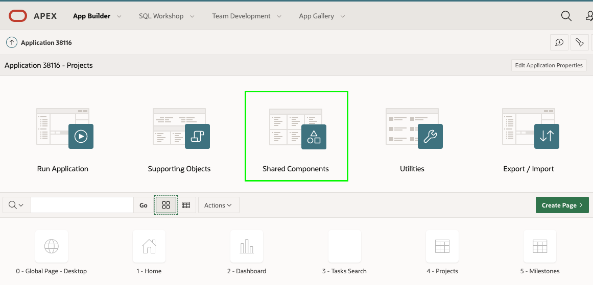

Alternatively, if in Page Designer, within the toolbar, click the **Shared Components** icon.

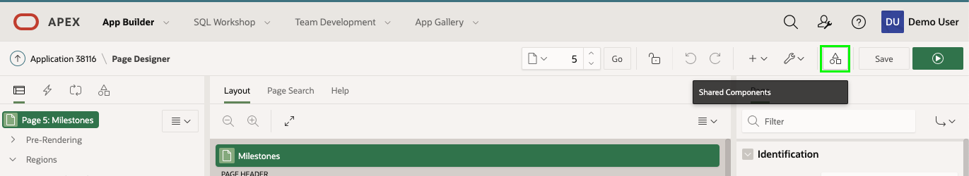

1. On Shared Components, under **Other Components**, click **List of Values**.

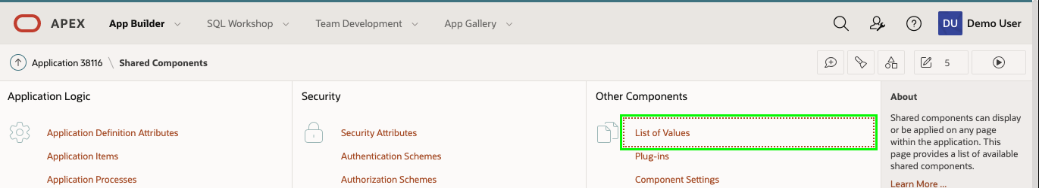

1. You will notice there are already several LOVs listed.  
   To create a new LOV click **Create**.

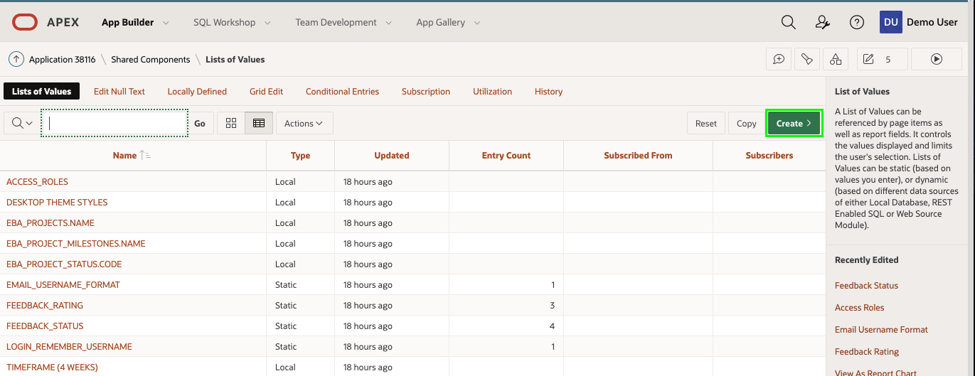

1. On the Create List of Values dialog, for Source, keep the default selection ("From Scratch"). Click **Next**
2. On the Name and Type dialog, enter the following:
   * Name - enter **YES_NO**
   * Type - select **Static**
3. Click **Next**

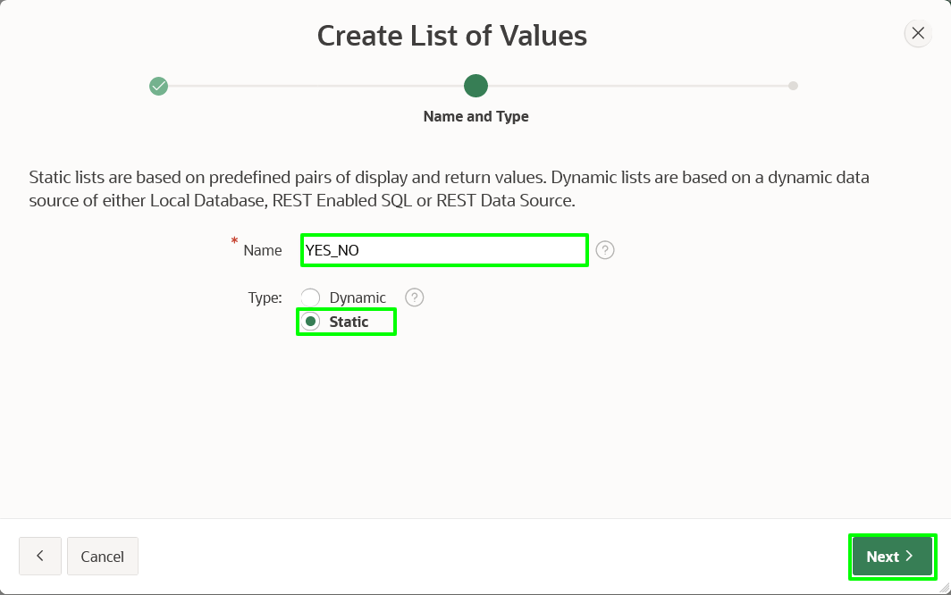

1. On the Static Values dialog, enter the following:
   * Sequence 1
     + Display Value - enter **Yes**
     + Return Value - enter **Y**
   * Sequence 2
     + Display Value - enter **No**
     + Return Value - enter **N**
   * Click **Create List of Values**

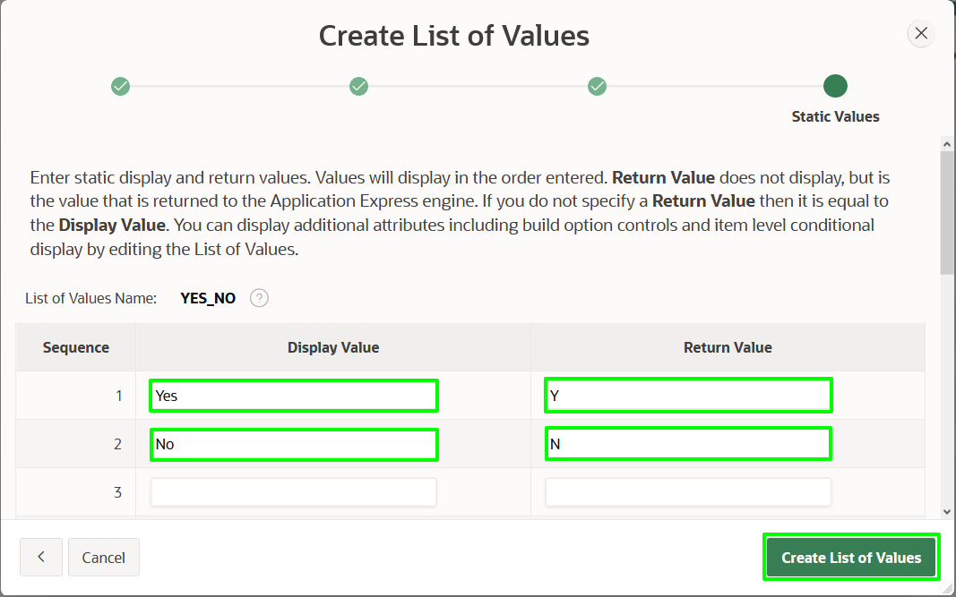

**Task 2: Updating the Faceted Search**

Now that you have defined the shared component, you need to utilize it on the Faceted Search page.

1. In the breadcrumbs, click **Application xxxxx**

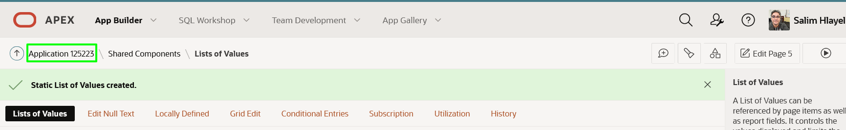

1. From the application home page, click **3 - Tasks Search**

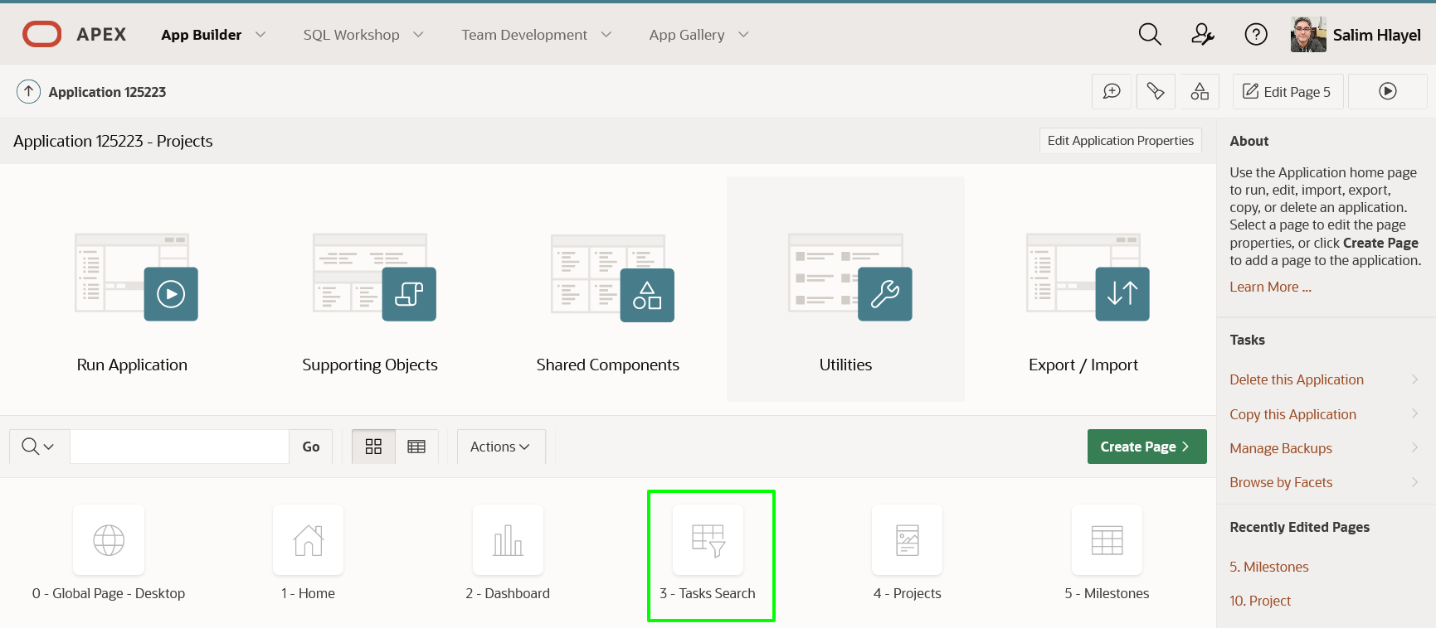

1. You first want to update the entries in the *Search*.
   * Within Page Designer, in the Rendering tree (left pane), under Search, click **P3_IS_COMPLETE_YN**.
2. In the Property Editor (right pane), select the following:
   * List of Values > Type - select **Shared Component**
   * List of Values > List of Values - select **YES_NO**

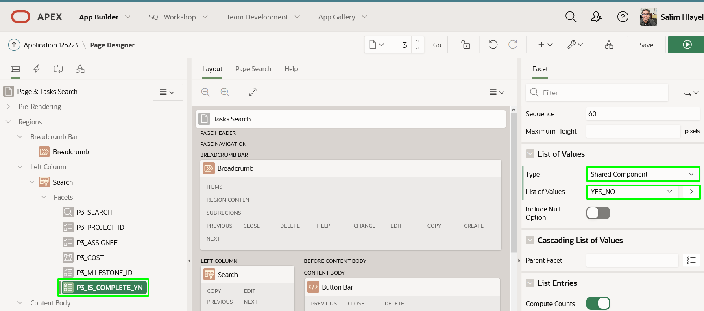

1. Next you also want to update the displayed value in the *Report*.
   * In the Rendering tree (left pane), under **Project Tasks**, expand **Columns**.
   * Within the list of columns, click **IS_COMPLETE_YN**.
2. In the Property Editor (right pane), enter the following:
   * Identification > Type - select **Plain Text (based on List of Values)**
   * List of Values > Type - select **Shared Component**
   * List of Values > List of Values - select **YES_NO**

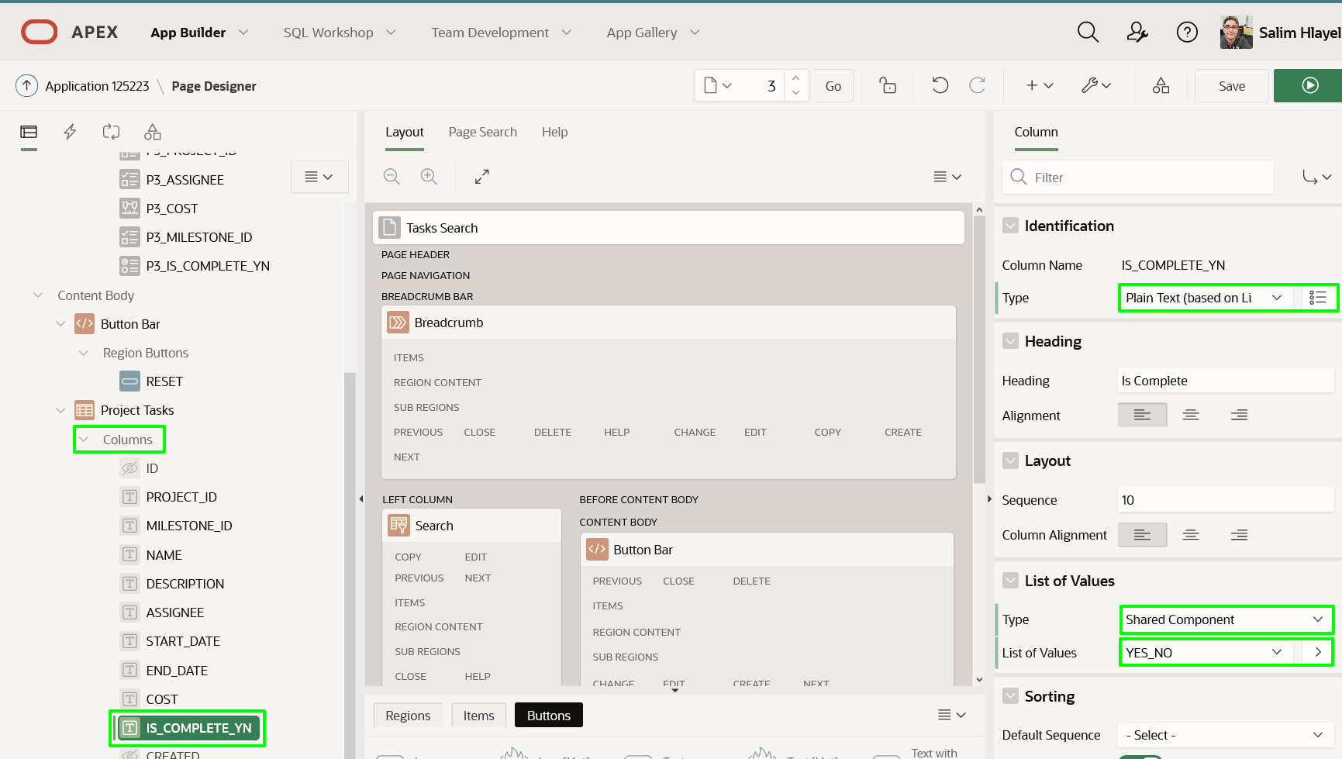

1. The report has many columns. The Description column takes up too much real estate, so should be hidden.
   * In the Rendering tree (left pane), under **Project Tasks**, within the list of columns, click **DESCRIPTION**.
   * In the Property Editor (right pane), for Identification > Type select **Hidden Column**.

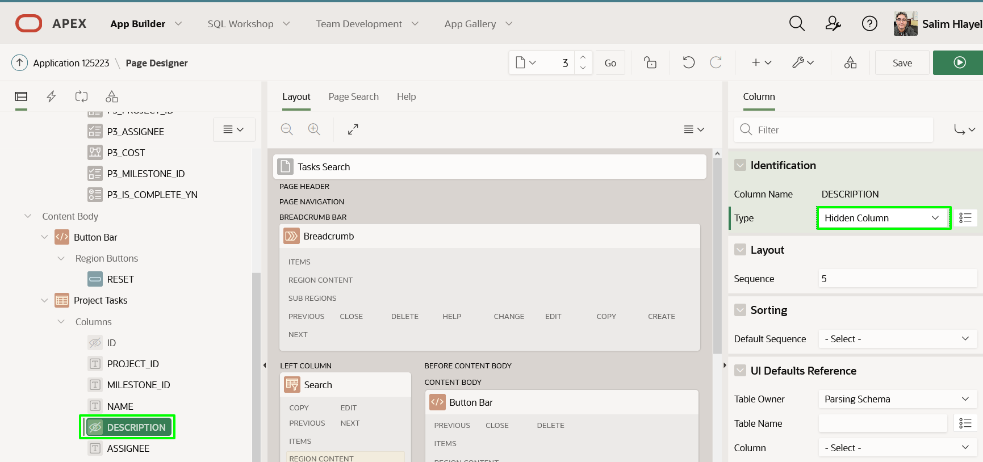

1. While we are on the page, we can quickly change the order of the search columns.
   * In the Rendering tree (left pane), under **Search**, click **P3_MILESTONE_ID**
   * In the Property Editor (right pane), for Layout > Sequence enter **25**  
     *Note: This will position P3_MILESTONE_ID after P3_PROJECT_ID (Sequence 20)*
   * In the Rendering tree (left pane), click **P3_IS_COMPLETE_YN**
   * In the Property Editor (right pane), for Layout > Sequence enter **35**  
     *Note: This will position P3_IS_COMPLETE_YN after P3_ASSIGNEE (Sequence 30)*

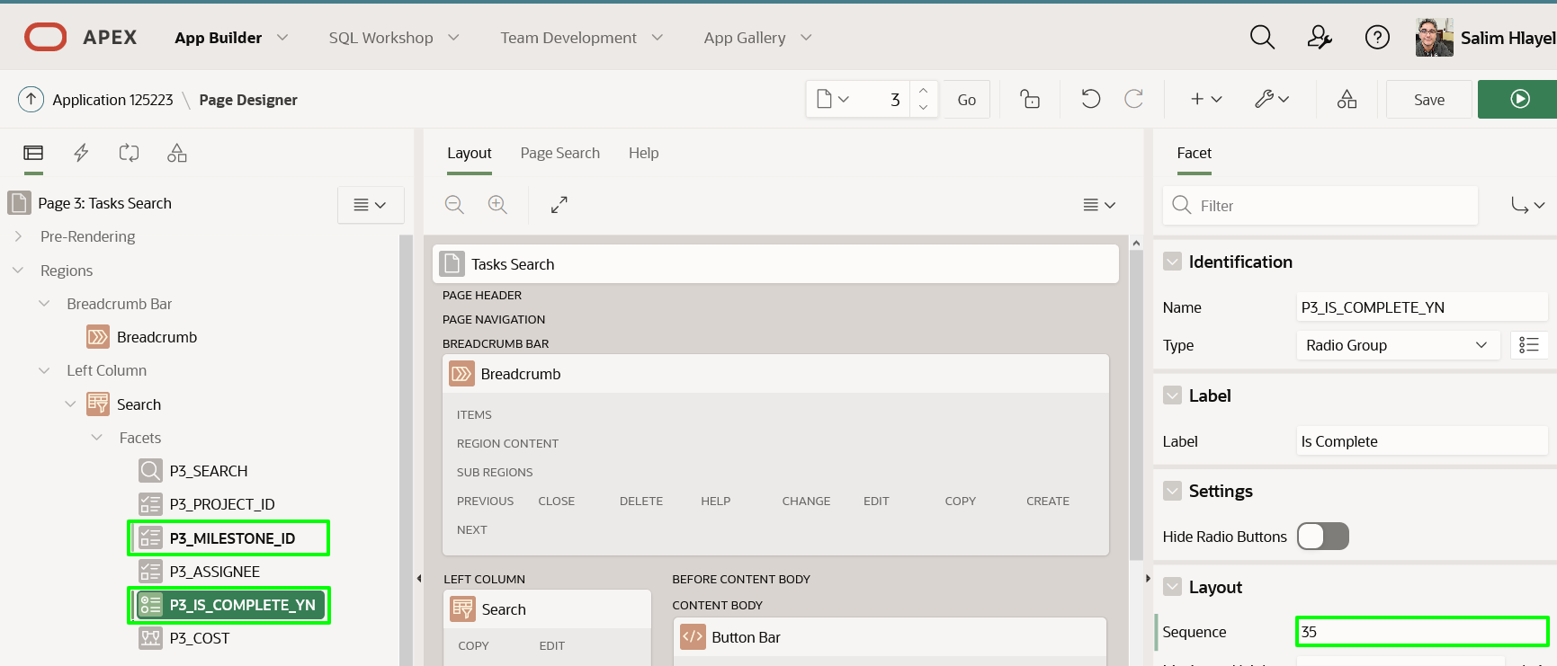

1. Let’s review that the Faceted Search is complete.
   * In the Page Designer toolbar, click **Save and Run Page**.

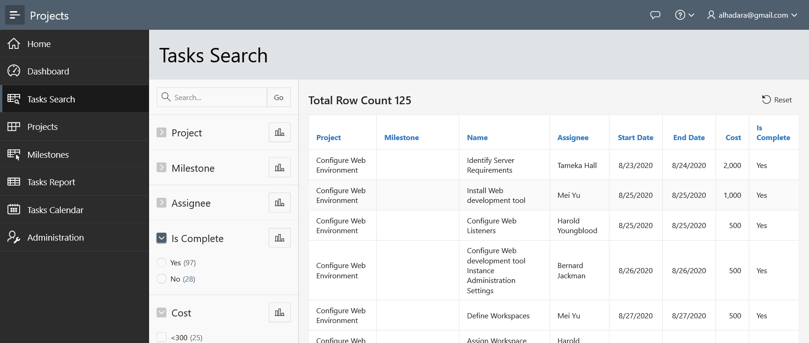

**Task 3: Updating the Interactive Report**

The Tasks Report also needs the Is Complete column updated.

1. In the Runtime environment, click **Tasks Report** in the menu.
   * In the Developer Toolbar (bottom of page), click **Edit Page 6**.  
     *Note: You can also navigate back to your application home page in the App Builder browser tab and manually navigate to Page 6*
2. In Page Designer, with **Page 6: Tasks Report** selected, in the Rendering tree (left pane), under **Project Tasks** region, expand **Columns**.
   * In the list of columns, click **IS_COMPLETE_YN**.
3. In the Property Editor (right pane), enter the following:
   * Identification > Type - select **Plain Text (based on List of Values)**
   * List of Values > List of Values - select **YES_NO**

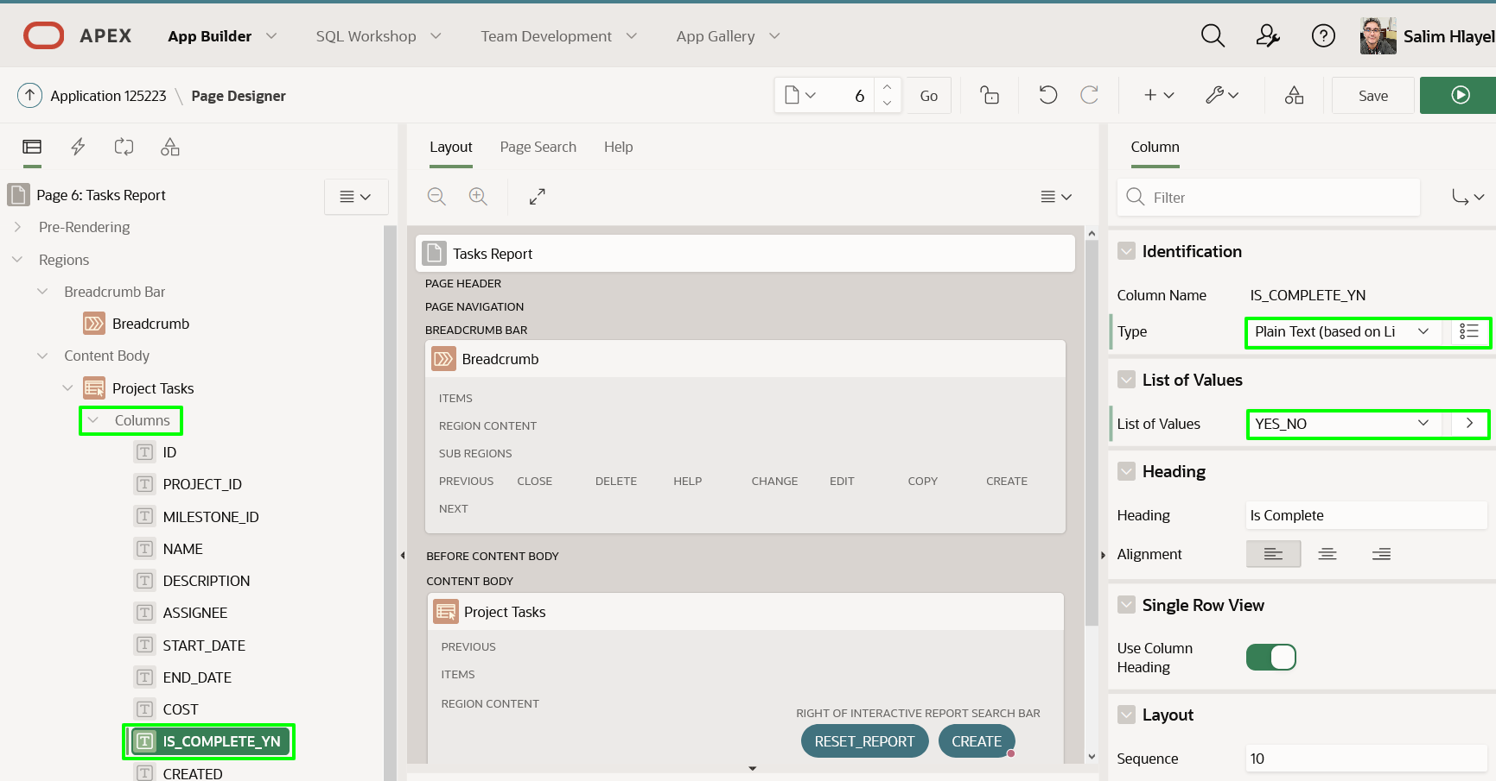

1. Run the application.  
   In the Page Designer toolbar, click **Save and Run Page**.

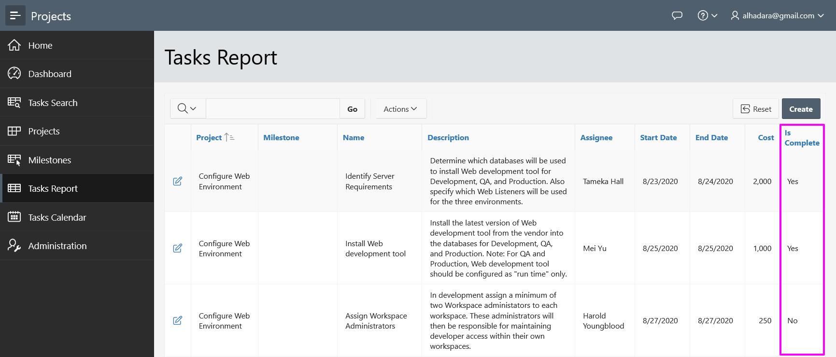

1. Click on the edit icon for a record.  
   Notice that Is Complete uses a Switch so no need to modify the Form page.  
   *Note: The Form page is Page 7 which we will need in the next part*

**Task 4: Linking the Calendar**

The Tasks Calendar page shows numerous tasks; however, there is no way to directly modify a record. Therefore, you should add a link to the existing Project Task Form page.

1. In the runtime environment, within the Navigation Menu, click **Tasks Calendar**
2. Click on any entry to confirm it simply displays the event details

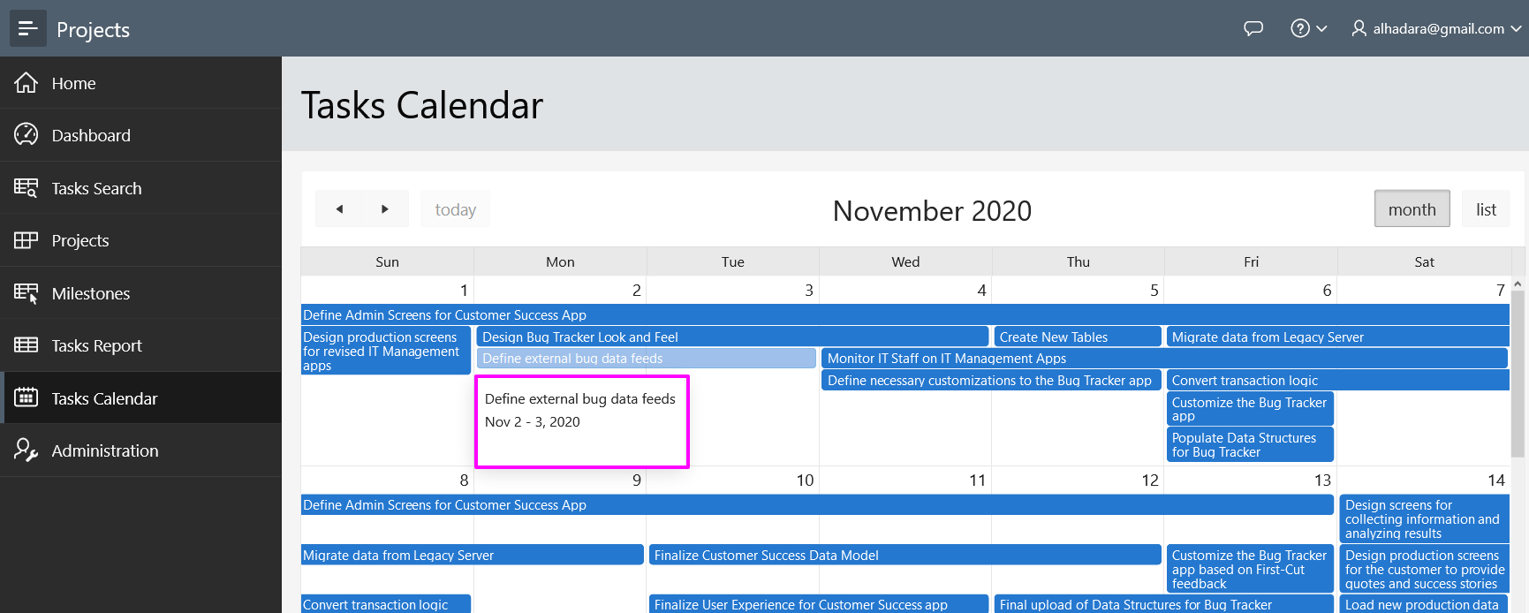

1. In the Developer Toolbar (bottom of page), click **Edit Page 8**
2. In Page Designer, within the Rendering tree (left pane), under **Tasks Calendar** region, click **Attributes**.
   * In the Property Editor (right pane), for Settings > View / Edit Link, click **No Link Defined**
3. In the Link Builder dialog, enter the following:
   * Target > Page - select **7**
   * Set Items > Name - select **P7_ID**
   * Set Items > Value - select **ID** (Returns **&ID.**)
   * Clear / Reset > Clear Cache - enter **7**
4. Click **OK**

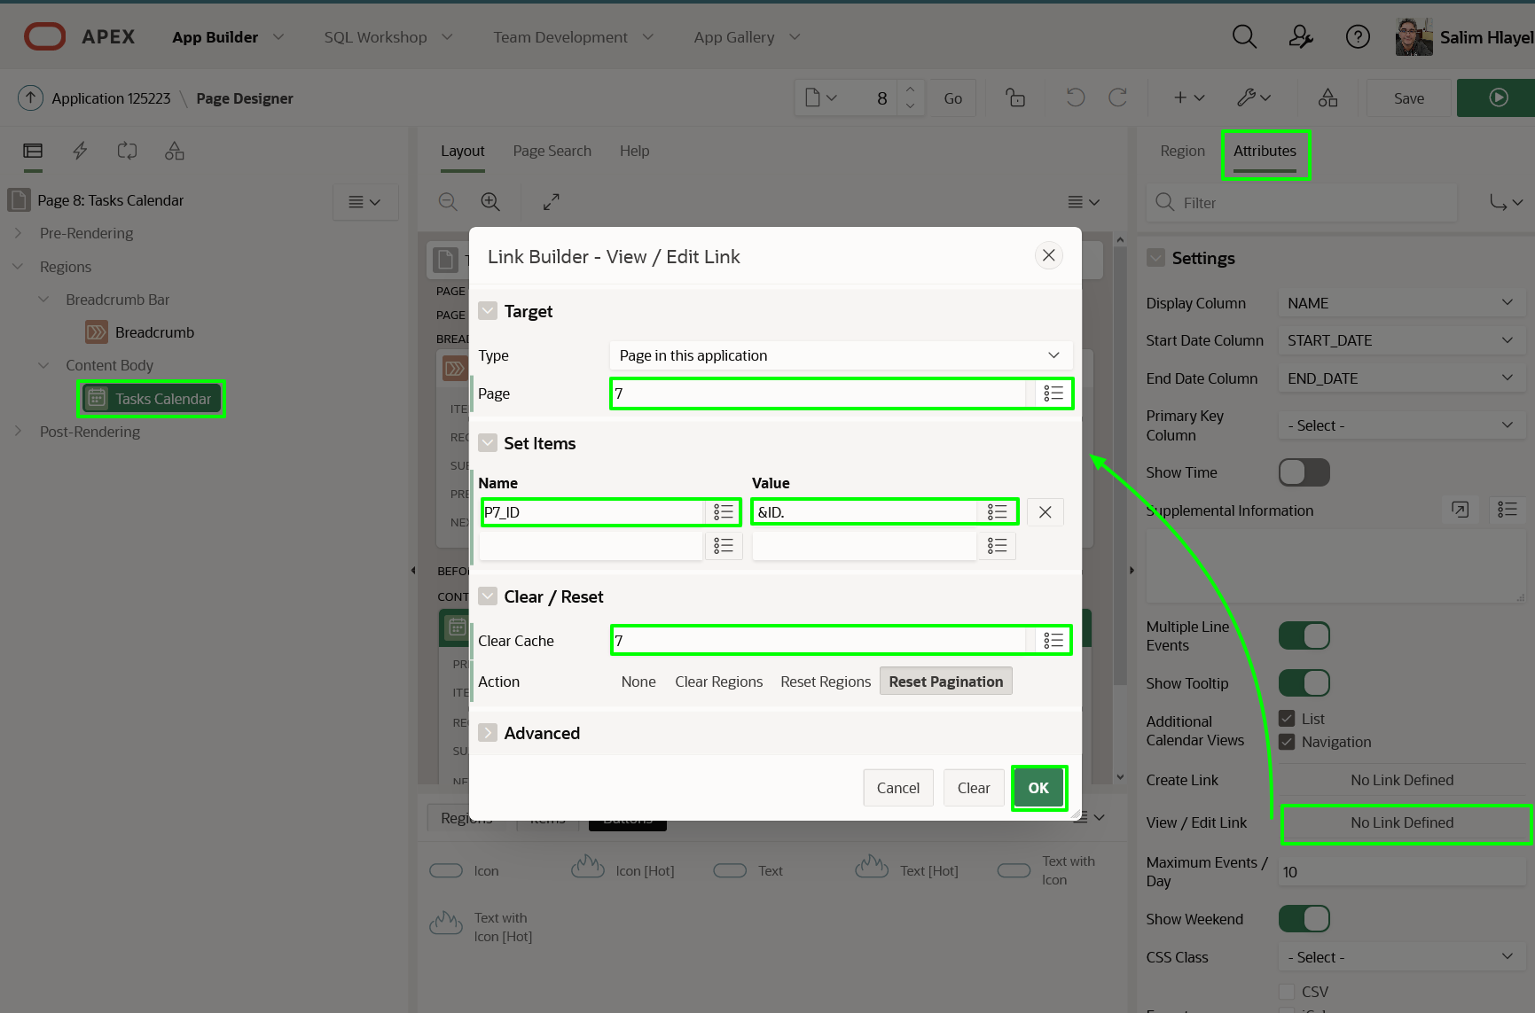

1. It is important that the calendar is updated if the Task Name, Start Date, or End Date are updated when the Project Task Form page is called from the calendar.
   * In the Rendering tree (left pane), *right-click* **Tasks Calendar**.
   * Select **Create Dynamic Actions**.

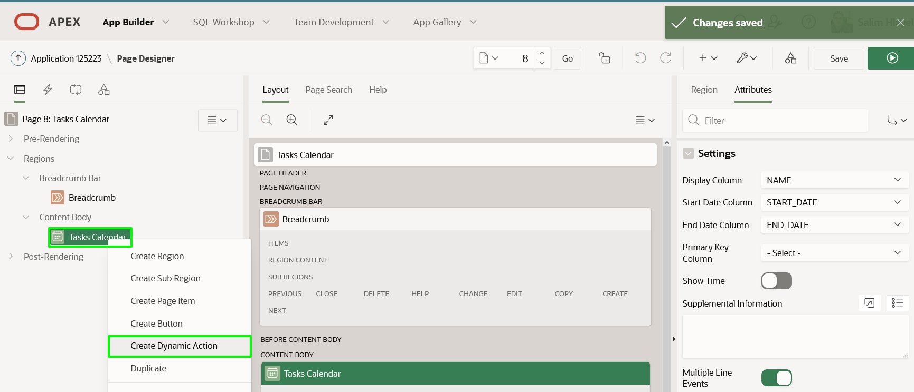

1. With **New** under Dynamic Actions selected, in the Property Editor (right pane), enter the following:
   * Identification > Name - enter **Refresh Calendar**
   * When > Event - select **Dialog Closed** (under **Framework Events**)

*Note: The Refresh Calendar event will fire when the Project Task Form page is closed as it is a modal page*

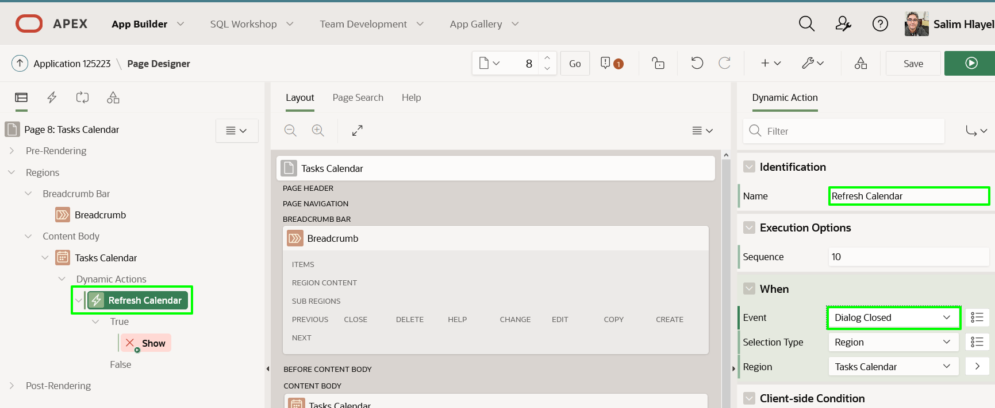

1. In the Rendering tree (left pane), under the True action, click **Show**.  
   In the Property Editor (right pane), select the following:
   * Identification > Action - select **Refresh** (under **Component**)
   * Affected Elements > Selection Type - select **Region**
   * Affected Elements > Region - select **Tasks Calendar**

Click **Save**

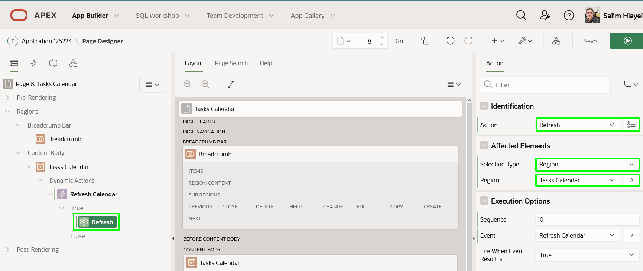

1. Navigate back to the runtime environment, and refresh the browser.
   * Click a calendar entry

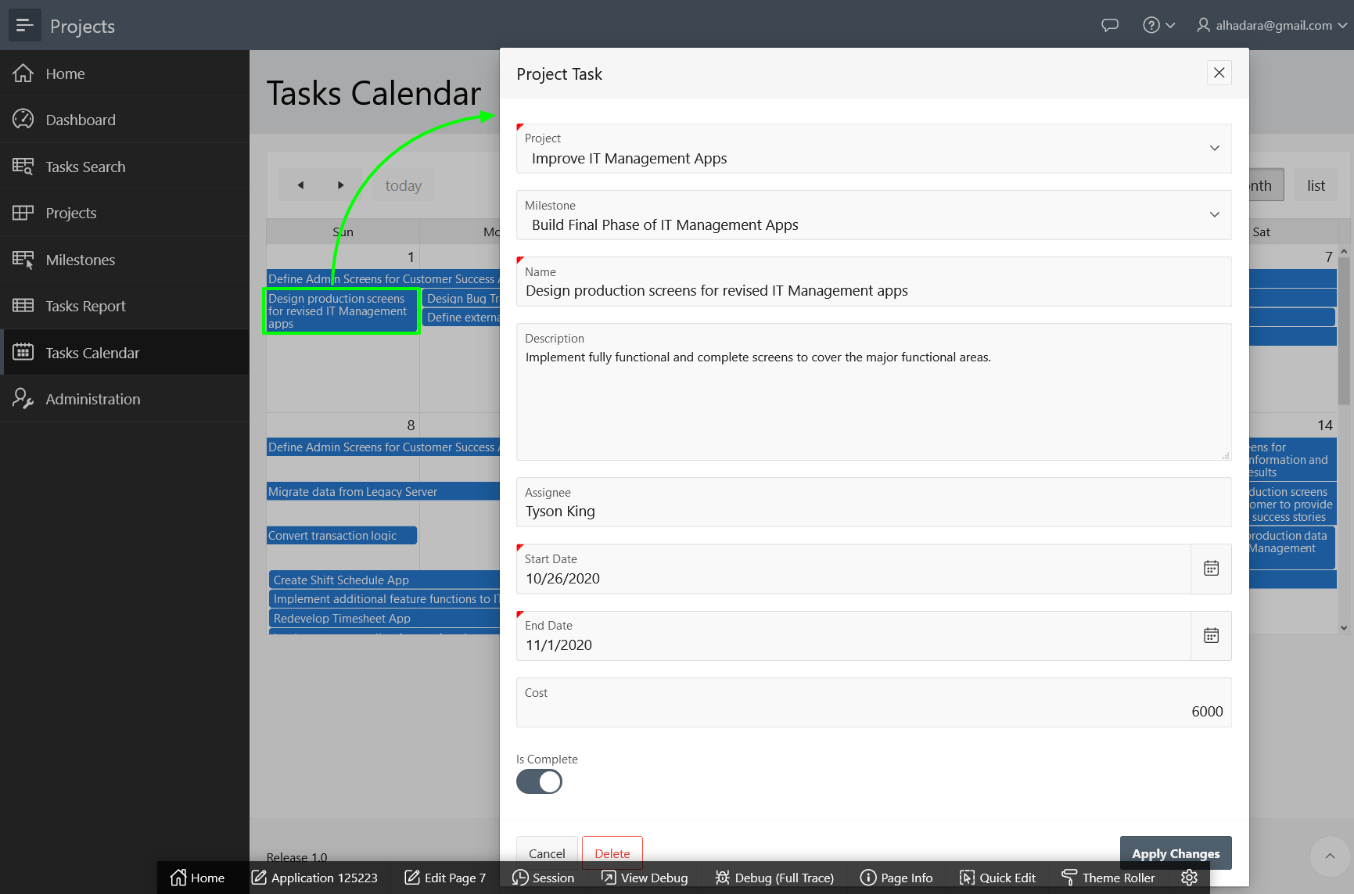

If you update the Name, Start Date, or End Date, and click **Apply Changes** on the Project Task Form page, the changes will be reflected immediately in the calendar.

**Summary**

This completes Lab 7 and the workshop. You now know how to create a Shared Component, use it to improve Faceted Search page and Interactive Report, and link a Calendar page that refreshes after a record is updated.